|  |
| --- |
|  |
| CIMI-Sponsored HL7 IIM&T Project #1316“*Integration of Information Models and Tools*” |
| **Sponsor:** Clinical Information Model Initiative (CIMI) workgroup at HL7  **Lead SMEs:** Keith Campbell, Stan Huff, Julia Skapik, Steve Wagner **Proponents:** ONC OST, FHA, DoD/VA IPO  **Facilitators:** Nona Hall and Steve Hufnagel  2017-04-04  ***Newsletter Acronyms are defined at the end.*** |

Published Newsletters available at <http://wiki.hl7.org/index.php?title=CIMI_Newsletters>

# CONTENTS

Introduction and Events 1

Executive Summary 2

Plans 3

Milestones 3

Pilot Projects 3

Feature Articles (SOLOR) 5

Feature Articles (Skin Pilot) 7

Discussions 14

Commentary 16

References 17

Acronyms 18

Attach: IIM&T Project Summary 19

|  |
| --- |
|  |
| EVENTSTuesdays **1500 ET: HL7 EHR WG**  Dial-in: (224) 501-3412, Code: 798-931-918 # <https://global.gotomeeting.com/meeting/join/798931918>  **1700 ET: SOLOR Team Meeting (bi-weekly)**  Dial-in: (202) 602-1295 Code: 105-163-321  <https://join.me/105-163-321> Wednesdays **1200 ET: HL7 CDS WG**  Dial in: (770) 657-9270, Code: 6870541# <https://global.gotomeETing.com/join/383926805>    **1400 ET: FHIM Terminology Modelling**  Dial in (571) 317-3122 Code: 783145837# <https://global.gotomeeting.com/join/783145837> Fridays **1100 ET – HL7 PC Skin/Wound Breakdown Risk**  Dial in: (770) 657-9270, Code: 943377# <https://www.callinfo.com/prt?host=level3&an=8663654406&ac=2933774>  **1300 ET – HL7 CQI WG**  Dial in: 770-657-9270 Code: 217663  <https://global.gotomeeting.com/join/474457221>  **1430 ET – FHIM Information Modeling** Dial In: (571) 317-3122, Code: 783145837#  <https://global.gotomeeting.com/join/783145837> PC: FHIM  **FHA Managing Board**  TBD  **HSPC Meetings**  May 23-24, for Developers, Salt Lake City, UT  Aug 2-4 2017 Washington DC or Chicago  Nov 13-15 Indianapolis, IN  **HL7 Meetings**  May 05-12, 2017 Madrid, Spain  Sep 09-15, 2017, San Diego, CA |

**Requested Action**: Please send questions, feedback and suggestions to [Stephen.Hufnagel.HL7@gmail.com](mailto:Stephen.Hufnagel.HL7@gmail.com) and/or [Nona.G.Hall.civ@mail.mil](mailto:Nona.G.Hall.civ@mail.mil)

|  |
| --- |
| Introduction This newsletter provides current Clinical Information Models and Tools (IIM&T) Project status, challenges and plans; where, its objective is to keep co-sponsors, stakeholders and proponents informed and engaged. As with our first Newsletter, its timing is to extend possible participation in upcoming events such as the May HL7 Working Group Meeting. IIM&T was formulated by SMEs and is endorsed by a solid base of stakeholders. This newsletter supports Communications which is one of the three tenets of this project. The other two, namely, the Integration work, supplemented by Governance, capitalize on our near term efforts to progress project accomplishments and challenges for which, recent accomplishments are showcased herein.  *While injection of additional resources is certainly needed moving forward, we are currently making the most of here-and-now efforts-and-meetings to demonstrate the merits of the integration of information models, enabled by tooling in order to bolster implementation assets such as, but not limited to, FHIR.*  Contributions are in turn acknowledged as offered by the FHA, DoD/VA IPO, ONC, VA, DoD, PenRad, Intermountain Healthcare Systems, etc. IIM&T participants know the science of semantic interoperability is complex and not well understood. In the Figure 8 Problem: Skyscraper Analogy, which is detailed on page 23, there are currently many overlapping efforts seeking to build the ultimate interoperability skyscraper, starting however on the third floor, without a sufficient foundation. To better our current healthcare delivery systems and position our industry for the ultimate Learning Health System where the data and stakeholder demands are greater, the IIM&T effort seeks to codify and offer what is regarded as the missing link; the requisite foundation to semantic interoperability. Your feedback and suggestions in this quest to communicate the benefits of this evolving work are welcome. |
|  |

# Executive Summary

Achieving high patient-value should be the overarching healthcare delivery goal, defined as health outcomes achieved per dollar spent. The achievement of this goal is what matters for both patients and clinicians, and serves to unite the diverse interests of all participants within the healthcare system. As patient value improves, payers, providers, and suppliers all benefit from the achievement of improved economic-sustainability.

Integration of Information, Models & Tools (IIM&T) serves to deliver CLIM, CDA and FHIR standards; whereas the CIMI-compliant Common Logical Information Model (CLIM) incorporates elements of SOLOR, FHIM, CIMI and CQF to specify CDA and FHIR profiles-and-extensions. IIM&T’s methodology can enable a well-functioning healthcare system where the creation of patient-value is utilized to determine the resulting value to all healthcare-system stakeholders.

## Technical Overview

**CIMI’s goal** is “to help people live the healthiest lives possible”, by bringing about “Learning Healthcare Systems supporting Precision Medicine.” Our current-state legacy data is discordant and cannot efficiently or effectively support modern clinical needs. IIM&T’s methodology uses shared reusable-models as a basis to support Learning Health Systems interoperability, thereby supporting Precision Medicine by maintaining semantically-consistent and requirements-traceable computable data, including situational data (who, what, when, where, and how) across different platforms, populations, applications, etc.

**IIM&T’s methodology** starts with coordinated standardization of the harmonized CIMI-FHIM-SOLOR-CQF logical information models, which is composed of a rich collection of re-usable requirements and information artifacts used to specify computable patient health data-sets, which are compose-able into higher level, actionable patient information. IIM&T’s methodology maintains a clean separation of clinical model semantics using a SOLOR (SNOMED with LOINC and RxNorm extensions) terminology foundation. SOLOR can eliminate structural and terminology modeling semantic-overlap in supporting CDA or FHIR development. Thus far, FHIR has proven adept at addressing needs of the implementation community; however even the best of implementation accelerators, like FHIR with its extensions and profiles, allows for far too much variation between implementation projects to provide for assured semantic interoperability.

**IIM&T’s value-proposition** centers on better quality of patient-care, supported by efficient and effective data-and-requirements change management at reduced cost, while maintaining the harmonization of stakeholder perspectives, initiatives and ultimately reuse libraries of model driven development (MDD) tools, components, applications and systems, thereby producing value (improved patient-safety and quality-of-care at reduced costs).The evolving IIM&T methodology has healthcare providers retain ownership of models, via HL7 participation, and technology, via HSPC participation; where, vendors, clinicians and other stakeholders can optimize their areas for productivity, while managing the impact of change in clinical practice, technology, profit, legislation and policy requirements. The IIM&T value-proposition is based on patient-care lessons-learned, for driving efficient and effective MDD optimization of healthcare value recovery.

Healthcare value remains largely unmeasured and misunderstood; where, improving healthcare value depends on having a shared goal that unites stakeholder interests and activities. Healthcare stakeholders have a myriad of often conflicting goals, including access to services, profitability, quality, cost containment, safety, convenience, patient centeredness and satisfaction. Lack of clarity regarding goals has led to divergent approaches, locally optimized manipulation of the healthcare system, and resultant insufficient progress in healthcare system stakeholder perspectives as defined around patient value; where, in a well-functioning healthcare system, the creation of patient value must inform and determine the value to all individual stakeholders within the system.

The IIM&T methodology is being refined within both the HL7 standardization and the HSPC legal-framework for government, industry and academia to collectively develop value-add applications. Rigorous and disciplined clinical value measurement, coupled with agile MDD value refinement and improvement provides the best way to drive value improvements. Patient-value depends on results, not the volume of services delivered, nor is it measured by the process of care. Process measurement and improvement are important actions, but do not substitutes for nor supplant directly measuring value (outcomes relative to costs). Cost reduction without regard to the outcomes achieved is both dangerous and self-defeating, leading to false representation of “savings” and potentially limiting the realization of safe and effective care. Shifting business-models from volume to patient-value is an ongoing challenge, yet is a strategic imperative to achieving Learning Healthcare System success.

## Plans

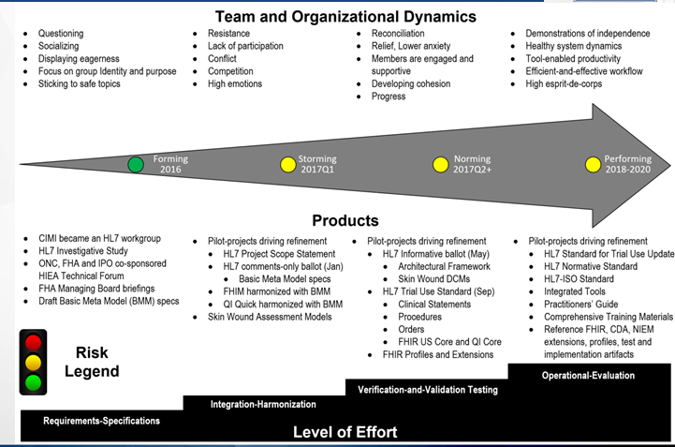

Figure 1: IIM&T 2017Q1 Status and Plan

## Recent Activities and Milestones

* January 2017 - CIMI-sponsored HL7 Basic Meta Model Comments-only ballot.
* March 2017 - Skin and Wound Assessment Pilot was presented at HSPC meeting
* The FHIM, CQI/CDS and CIMI teams are refactoring the FHIM Domain Class Models and CIMI Basic Meta Model (**BMM**) with the new Clinical Statement Reference Architypes and Patterns, derived from the Skin / Wound Assessment Pilot Project.
* CQI and CDS workgroups 2017 plans include completing CQL 1.2, the FHIR Clinical Reasoning Module (formerly CQF-on-FHIR IG) and the QI Core FHIR Profiles.
  + QI Core is being updated to be derive from FHIR US Core (formerly DAF Core), and several production projects are in progress or planned for 2017.
* SOLOR is being updated to support the Skin & Wound Assessment project.
* A web-based browser was developed for the
  + CIMI BMM web-browser, see <http://models.opencimi.org/cimi_doc/>
  + CIMI Architype and DCM web-browser, see <http://models.opencimi.org/>

## 2017Q1 Focus: FHIM, CQF and CIMI Harmonization

**2017Q1 FHIM, CQF and CIMI Architectural Framework, principles and methodology harmonization**

* Continuing to re-factor the FHIM to harmonize with CIMI, CDS, and CQI
  + Completed re-factoring of Provenance and “Attribution” to fit the “Clinical Statement” pattern. This affected every clinical package in the FHIM
  + Completed re-factoring of Subject of Information / Subject of Record to fit the “Clinical Statement” pattern. This affected every clinical package in the FHIM
  + Completed analysis of the Statement Topic / Context pattern to harmonize with CDS, CQI, and SOLOR. This re-factoring separates the subject matter in each class from its context.
* Began to implement the re-factoring in Encounters and Pharmacy.

**Harmonizing FHIM with FHIR STU 3**

* FHIR Standard for Trial Use (STU 3) has substantially changed since the last review conducted in September 2016. At this time we are combing through the current STU 3 (which has now been locked down for publication) and identifying changes needed to the FHIM for alignment and compatibility.

**Preparing to refresh the Security / Privacy Model**

* Security and Privacy have evolved substantially since the approximately 2010 models incorporated into the FHIM. This is in part driven by FHIR STU 3, but also impacted by ONC sponsored initiatives and implantation experience at SMART on FHIR. The FHIM team will review the latest materials from HL7 and from the VA.

**Terminology Modeling Project**

* Completed Terminology modeling of the “Assessment” (aka Questionnaire) domain
* Completed Terminology modeling of the Laboratory concepts that were tabled awaiting the outcome of the Public Health Laboratory project
* Tabled Enrollment/Eligibility/Coordination of Benefits terminology modeling. A majority of these concepts currently reference proprietary value sets, but HL7 FHIR currently is working on an international version that will warrant review.
* Began a scrub of previously modeled terminology concepts to ensure that they’re still current given the many changes in FHIR (along with HL7 v 2.9 which is imminent and changes how HL7 references v2 value sets)
* Preparing to engage the Security workgroup’s information modeling to incorporate proper value sets

**CIMI Architectural Framework**

* The CIMI clinical layer-3 BMM Reference Architypes and layer-4 Patterns were updated, in accordance with the Skin and Wound Assessment pilot-project requirements.
* Skin and Wound Assessment pilot-project Detailed Clinical Models (DCMs) are planned to be completed in Q2’ 2017.
* The updated HL7 CIMI Architectural Framework May ballot materials were submitted.

## 2017Q1 Collaboration Pilot-Projects*

* FHIM integration of CIMI Clinical BMM & Archetypes (Patterns) #1 [Galen Mulrooney]
* US Core / QI Core integration of CIMI BMM & Archetypes (Patterns) #1 [Claude Nanjo]
* Refine PROCEDURE and CONTEXT based on Pilots #1 (Galen Mulrooney and Claude Nanjo)
* Patient Care Project #1253 "CIMI Clinical Model Proof of Concept" (Skin Wound Assessment) #1
* Pediatric Bilirubin Management CDS #2, needs code generation library [Ken Kawamoto]
* Zika measure #3 [Ken Kawamoto and Claude Nanjo]
* Immunization Management EHR Functional Model Profile #3 (Steve Hufnagel and Gary Dickinson)
* Family Planning Annual Report (FPAR) – HSPC pilot with ACOG #3 [Stan Huff, Susan Matney]
* Device interfaces MDEpiNet #3 [Julia Skapik, ONC and Terri Reed, FDA]
* FHIR JET (Joint Exploratory Team) #3 Nona Hall, IPO, VA, DoD

* Where, #1, #2 or #3 indicates May-2017 HL7 Ballot inclusion-priority.

*For HL7, HSPC and the IIM&T project to be timely and effective, injection of resources is certainly needed, we are making the most of here-and-now efforts-and-meetings to demonstrate the merits of the integration of information models, enabled by tooling in order to bolster implementation assets such as, but not limited to, FHIR.*

# Feature Article: SOLOR Foundation of IIM&T Project

Keith Campbell and Susan Matney

SOLOR supports CIMI in-accordance-with the **Figure 9 IIM&T** Model Driven Development Strategy in conjunction with the FHIM, CQF and SOLOR teams.

## SOLOR

SOLOR (SNOMED with LOINC and RxNorm extensions) is endorsed by the HSPC as a terminology foundation for interoperable decision support. CLIM (FHIM, CQF, CIMI) will use SOLOR as a single integrated terminology which incorporates several terminology standards, including; but not limited to: SNOMED, RxNorm, and LOINC, into a logically integrated—and structurally normalized—foundation. While the three core-standards cover different types of content, SOLOR harmonizes the overlap between them, lending to opportunities for greater interoperability between systems. SOLOR will be the terminology content utilized within the Federal Health Information Model (FHIM), Clinical Quality Framework (**CQF**), and the Clinical Information Modeling Initiative (**CIMI**).

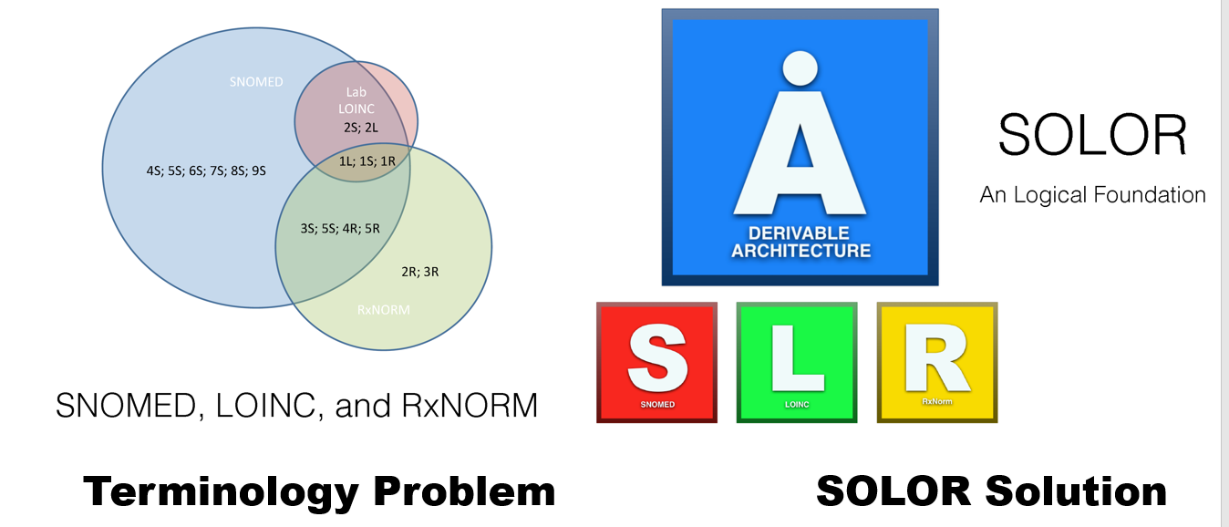

Figure 2: SOLOR with SNOMED extensions solve LOINC and RXNorm inconsistencies

SOLOR is the terminology content, based on the SNOMED CT Observation Model; where, SNOMED CT serves as a source of concepts for SOLOR semantic buildings as well as inferences. LOINC and RxNorm will be integrated into SOLOR using SNOMED CT’s shared Descriptive Logic (**DL**) model. DL terminologies are foundational allowing additional models to be built on top of, not independent of, the foundation. The benefits of having this normalized structure and form is that clinical terminology includes:

1. Improving software reuse;
2. Facilitating shared tooling;
3. Using a shared post-coordination model; and
4. Simplifying data analysis.
5. Allowing automated-reasoning aka logical-inferences

## LEGO

The Lightweight Expression of Granular Objects (**LEGO**) model is separate from SOLOR; but, LEGOs can also provide semantic model content and can be used to test the validity and consistency of models. LEGO construction is a content-modeling strategy based on the International Health Terminology Standards Development Organization (**IHTSDO**) Observables Model, which is for use in the Systematized Nomenclature of Medicine – Clinical Terms (**SNOMED CT**).

LEGOs can represent large amounts of detailed clinical data in a consistent and computable manner that can support multiple use cases. LEGOs represent question/answer pairs on clinical data collection forms, where a question is modeled by a (usually) post-coordinated SNOMED CT expression. LEGOs transform electronic patient data into a normalized consumable, which means that the expressions can be treated as extensions of the SNOMED CT hierarchies for the purpose of performing subsumption queries and other analytics. Using the LEGO approach for modeling clinical data provides a foundation for data exchange across disparate information systems and software applications. Clinical data exchange of computable LEGO patient information enables the development of more refined data analytics, data storage and clinical decision support.

When a LEGO discernible requires more than a single observable entity concept (in other words, when post-coordination is required), use of the IS ABOUT attribute is the preferred way to represent presence observables. The value of the IS ABOUT attribute in a LEGO discernible is frequently a SNOMED CT clinical disorder or procedure concept, while the <value> element of the assertion is often a SNOMED CT qualifier concept such as “Present” or “Absent.” The VA’s Informatics Systems Architecture Acceleration (**ISAAC**) project/editor LEGO Editor incorporates Lightweight Expression of Granular Objects (**LEGO**) functionality into the health IT Extraction, sharing and loading (**ETL**) software interoperability-stack.

## Termspace – Terminology Editing

Ontoserver® has been selected as the terminology server for HSPC. Ontoserver is a terminology server developed by the Commonwealth Scientific and Industrial Research Organization ([CSIRO](https://ontoserver.csiro.au/index.html)), based in Australia, that supports multiple versions of SNOMED CT (and extensions), LOINC and other standard terminologies. Ontoserver focuses on terminology use, not authoring. After the SOLOR content is authored in Termspace, it will be released as a Release Format 2 (**RF2**) module and loaded into Ontoserver.

Ontoserver contains a simple REST API and FHIR (Fast Health Interoperability Resources) STU3 terminology services, which will be accessed by applications using the SOLOR terminology content. Ontoserver is currently being configured with terminology content; where, a stable production version 1.0 is targeted to be available on or before 31 Oct 2017. “Shrimp” is the freely available Ontoserver SNOMED browser.

## Ontoserver – Terminology Server

Ontoserver® has been selected as the terminology server for HSPC. Ontoserver is a terminology server developed by the [CSIRO](https://ontoserver.csiro.au/index.html) Ontoserver that supports multiple versions of SNOMED CT (and extensions), LOINC and other standard terminologies. Ontoserver focuses on terminology use, not authoring. After the SOLOR content authored in Termspace, it will be released as a Release Format 2 (**RF2**) module and loaded into Ontoserver. Ontoserver contains a simple REST API and FHIR (Fast Health Interoperability Resources) terminology services (STU3) which will be accessed by applications using the SOLOR terminology content. Currently, Ontoserver is currently being configured with terminology content; where, a stable production version 1.0 is targeted to be available on or before 31 Oct 2017. “Shrimp” is the Ontoserver SNOMED browser.

## VSAC

The Value Set Authority Center (**VSAC**) is provided by the National Library of Medicine (**NLM**), in collaboration with the Office of the National Coordinator for Health Information Technology and the Centers for Medicare & Medicaid Services. The VSAC provides downloadable access to all official versions of vocabulary value sets contained in the 2014 electronic Clinical Quality Measures (**eCQMs**); where, each value set consists of the numerical values (codes) and human-readable names (terms), drawn from standard vocabularies such as SNOMED CT®, RxNorm, LOINC and ICD-10-CM, which are used to define clinical concepts used in clinical quality measures (e.g., patients with diabetes, clinical visit). For information on the eCQMs, visit the [electronic Clinical Quality Initiative (eCQI) Resource Center](https://ecqi.healthit.gov/). The content of the VSAC will gradually expand to incorporate value sets for other use cases, as well as for new measures and updates to existing measures.

In the short term, the current HSPC SOLOR Ontoserver serves as a sandbox development server; where, VSAC can be used for value sets and the HSPC Ontoserver server is used for code systems. This allows pilot studies to prototype SOLOR SNOMED extension requirements[1] and provide code-system requirements to NLM. CIMI plans to use VSAC exclusively, after the code system requirements are defined and stable and NLM‘s VSAC supports those code system requirements.

## STAMP Versioning

STAMP (Status, Time, Author, Module, Path) methodology will be used for the versioning and maintenance of Clinical-Knowledge content. STAMP is a comprehensive option for managing SOLOR version control and maintenance. The fundamental goal of STAMP is to provide a single, coherent and robust version control process that spans every layer and component involved in the authoring of clinical knowledge content; clinical decision support rules, clinical quality measures, value-set definition and the new expansions and extensions to existing clinical ontology concepts on which they will all depend. There will be STAMP repositories setup within HSPC for projects that span multiple clinical teams and communities to support critical, high-profile content development efforts.

STAMP is:

1. A standard for the metadata that must be retained during each editing event
2. An Open-Source implementation of the version-control web service.

The SMART architecture and schema for the metadata to be retained during the authoring process, is inspired by the best practices that exist in the software development community. Termspace and Ontoserver have been adapted to support the STAMP versioning platform.

By rationalizing version control practices across all layers of the clinical content stack, complex dependencies and release practices can be organized, administered and tracked as one. As clinical work-products are deployed in the field, and therefore must be maintained, robust tooling will exist to highlight and guide that maintenance effort.

By rationalizing version control practices across all layers of clinical content stack, complex dependencies and release practices can be organized, administered and tracked – as one. And as clinical work-products are deployed in the field, and therefore must be maintained, robust tooling will exist to highlight and guide that maintenance effort.

# Feature Article: Skin-and-Wound Assessment Pilot

The Jun 2016 HL7 Patient-Care Workgroup Project 1253 Skin-and-Wound Assessment pilot-study follows the **Figure 9 IIM&T** Model Driven Development Strategy found on page 24, which is being led by Jay Lyle and Susan Matney and supported by the FHIM, CQF and SOLOR teams.

## Background

This work was initiated in 2010 by a Kaiser Permanente and VA *Collaborative* effort to define a skin-breakdown risk-assessment information model, where the initiative was guided by nursing practice to enable; 1) data capture and data re-use, 2) data sharing within and outside organizations, and 3) EHR meaningful-use data measurement and extraction to support quality, safety, efficiency and decision support. Additional participants in the project included clinical informaticists from six organizations each running different EHRs. The preceding work was followed up in 2013 by an ONC Challenge Grant that mandated the model and terminology for Pressure Ulcer Assessment Mobilizing Data. In 2016, the pressure injury criteria were updated by the National Pressure Ulcer Advisory Panel (NPUAP, <http://www.npuap.org/>). All of this preceded CIMI at HL7; but, was a fortuitous precursor to be advanced in the Jun 2016 HL7 Patient-Care (PC) Workgroup Project 1253 (See <http://www.hl7.org/special/committees/projman/searchableprojectindex.cfm?action=edit&ProjectNumber=1253>)

* Using existing PC-defined clinical requirements to create a set of CIMI observation result models with semantic tags appropriate for automated classification.
* Following the Figure 9 IIM&T Model Driven Development Strategy (found on page 24)
* Developing DCMs as clinically-precise and technically-testable articulations of clinical requirements.
  + Demonstrate CIMI capability & identify additional DCM requirements from a PC perspective
  + Demonstrate how DAMs may be compositionally related to DCMs
  + Identify gaps in the traditional HL7 development framework
  + Demonstrate relationships between information models and logically computable expressions
* Demonstrating the feasibility of using DCMs to integrate the requirements & design phases of HL7 standards development
* Limiting content scope to be drawn primarily from the HL7 skin assessment DAM augmented to demonstrate critical requirements, such as negation.
* Phasing analysis to ensure key patterns (lab test, vital sign, and assessment instrument) can be represented before addressing how large numbers of clinical statements are assembled into compositions.
* Delivering the illustrated Figure 4 Skin-and-Wound Assessment UML Requirements Model (Page 10); where, the data elements are encoded with LOINC and are included in the LOINC [Wound Assessment Panel](https://s.details.loinc.org/LOINC/39135-9.html?sections=Simple).

For additional information, see Patient Care Skin-and-Wound Assessment Pilot Wiki[2]. A related project may implement these models in a model-driven design (MDD) specification generation tool (such as MDHT, Art Décor, or a FHIR server) to generate a specification, implement the specification in software, and test the requirements specifications; however these steps are not in scope for the June 2016 HL7 Patient-Care Workgroup Project #1253 project scope statement.

<https://drive.google.com/drive/folders/0B6NQrRuWFCvIeDhsY0JGR0pybzQ> for May ballot materials; Terminology can be found at: <https://docs.google.com/spreadsheets/d/15I7JfEauKCKfR3YdAIn7EVn6nzNwY_picVY8VVOAuBg/edit#gid=1525050999>

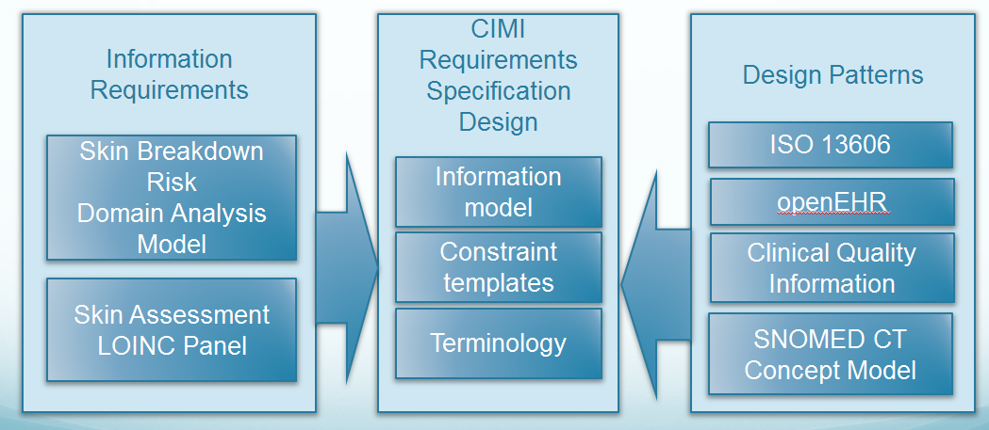

Figure 3 Skin and Wound Assessment Approach

The Figure 3 Skin and Wound Assessment Approach illustrated above is being adapted to the Figure 9 IIM&T Model Driven Development Strategy (page 24) and is being used to refine the IIM&T Architectural Framework, Methodology and technologies.

## Milestones and Plans

The Figure 3 Skin and Wound Assessment Approach generally align with these milestones:

* Pre 2016: Developed Skin Breakdown-Risk Assessment Q&A requirements spreadsheet. See [www.FHIMS.org](http://www.FHIMS.org)
* 2016: Analyzed the Skin & Wound Assessment Q&A requirements spreadsheet
* 2016Q4: Determined what was in and out of scope for the Skin & Wound Assessment
* 2016Q4: Developed CIMI BMM based-go DRAFT Skin-and-Wound Assessment Q&A requirements
* 2017Q1: Verified and validated Skin-and-Wound Assessment Q&A requirements with operational nurses
* 2017Q1: Aligned Questions with CIMI Patterns
  + Wound = assertion
  + Wound measurements = EvaluationResults
  + Defined how we are going to do “Panels”
* 2017Q1: Starting working with SOLOR on value sets
* 2017Q2: Develop CIMI Architypes, Patterns and DCMs.
* 2017Q3: HL7 Standard for Trial Use, including Skin and Wound Assessment Logical Information Models (LIMs) and FHIR profiles and Extensions exemplars.
* 2017Q4: Verify and Validate IIM&T Architectural Framework (Principles, BMM, architypes, patterns, DCMs, methodology) and technologies.
* 2018 A related project may implement these models in a model-driven design (MDD) specification generation tool (such as MDHT, Art Décor, or a FHIR server) to generate a specification, implement the specification in software, and test the requirements specifications; however these steps are not in scope for the Jun 2016 HL7 Patient-Care Workgroup Project 1253 project scope statement.

## User Story

The following **Pressure Injury** user story illustrates how the model and data can be used to encode patient, Peter Pepper’s, data.

* Peter Pepper is a 40-year old male military veteran with a 5-years old post lumbar spinal cord injury (obtained from a blast In Afghanistan). Peter Pepper is wheelchair bound and has no feeling from the waist down. He was admitted today for treatment of a stage four pressure injury with tunneling. The wound is 3 cm X 4 cm and 3 cm deep. There is a 3 cm tunnel in the two o’clock direction. The edge of the wound is boggy; where, Peter currently has Stage IV Pressure Injury, coupled with Chronic Pain, Chronic Depression and PTSD.

*Table 1 below* illustrate the encoding of Peter’s pressure injury with the wound measurements.

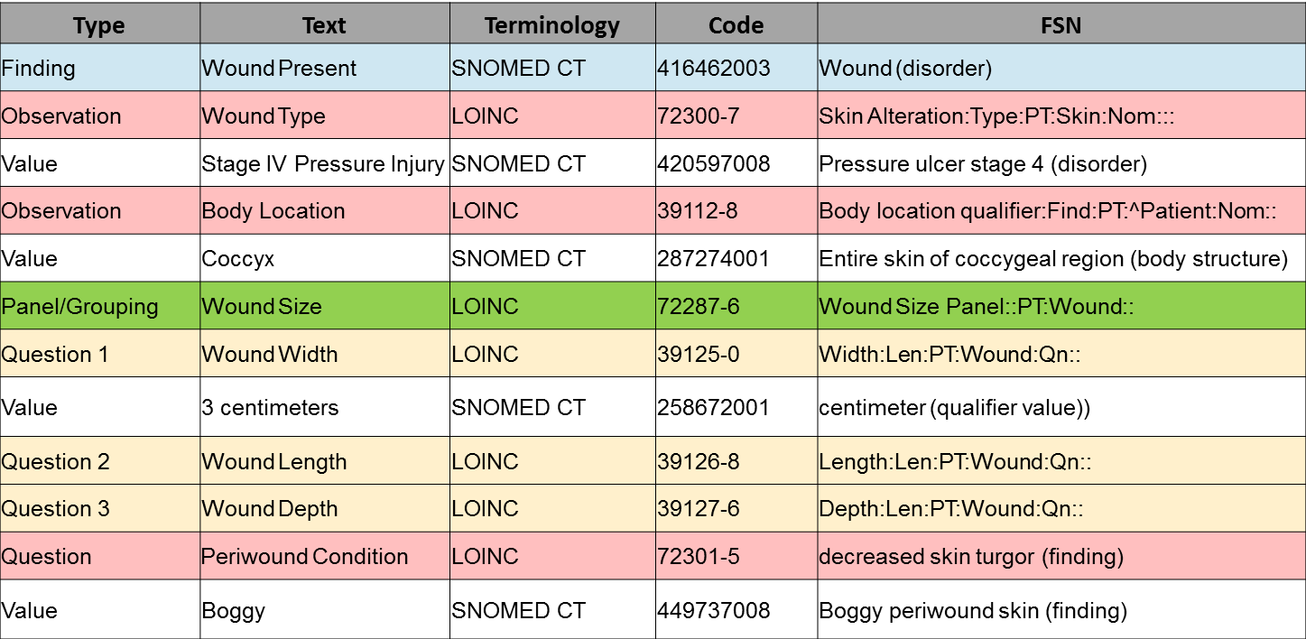

Table 1 LOINC Wound Assessment Panel is a snippet of the UML model illustrating how the Skin and Wound Assessment classes are related; showing how classes and their data element are constrained into a CIMI DCM.

Table 1 LOINC Wound Assessment Panel

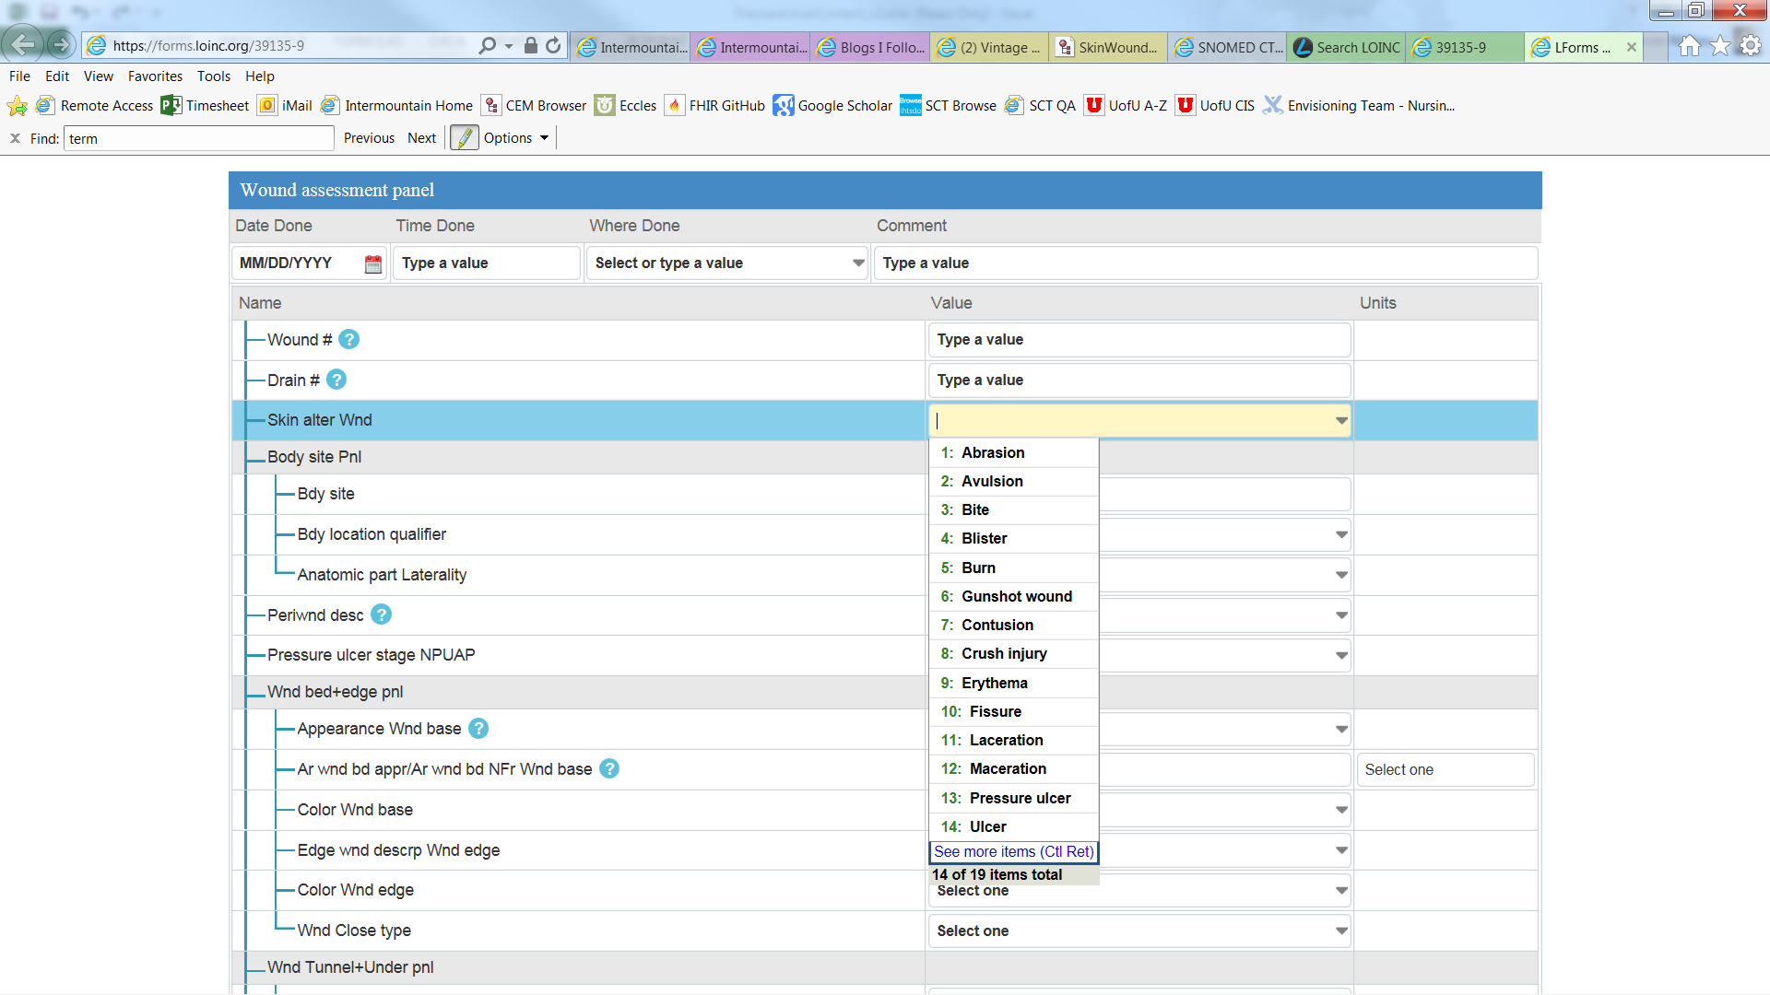

CIMI UML-BMM, including the FHIM is constrained into high-level Clinical Patterns, which were further constrained to develop Detailed Clinical Models (DCMs). The *Assertion* Architype was used to model conditions, symptoms and problems; where, a wound is a *Condition* further modeled as an *Assertion*. The *Evaluation Result* pattern was used to model *Clinical Observations,* such as the *Assessment Measures*. Each wound size was modeled using the *Evaluation Result Pattern*.

## Requirements

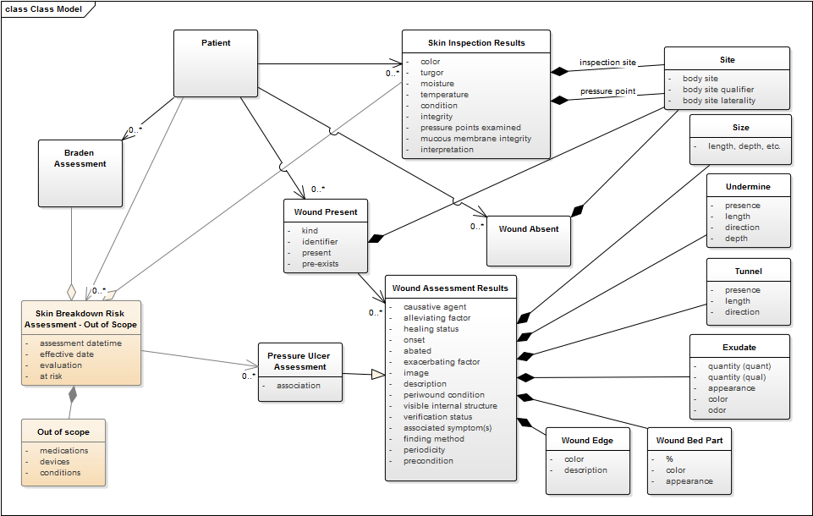

Figure 4 Skin-and-Wound Assessment UML Requirements Model

Figure 4 Skin-and-Wound Assessment UML Requirements Model was developed to help develop, verify and validate the CIMI BMM and Clinical-Architype Patterns. Figure 4 was also used to develop the *Assertion* Pattern used to model *Conditions, Symptoms and Problems*; where, a wound is a *Condition* and is modeled as an *Assertion* sub-class. The *Evaluation Result* Pattern was used to model a *Clinical Observation*, such as an *Assessment Measures* sub-class. Each wound size was modeled using the Evaluation Result Pattern.

Table 2CIMI DCM Data Elements

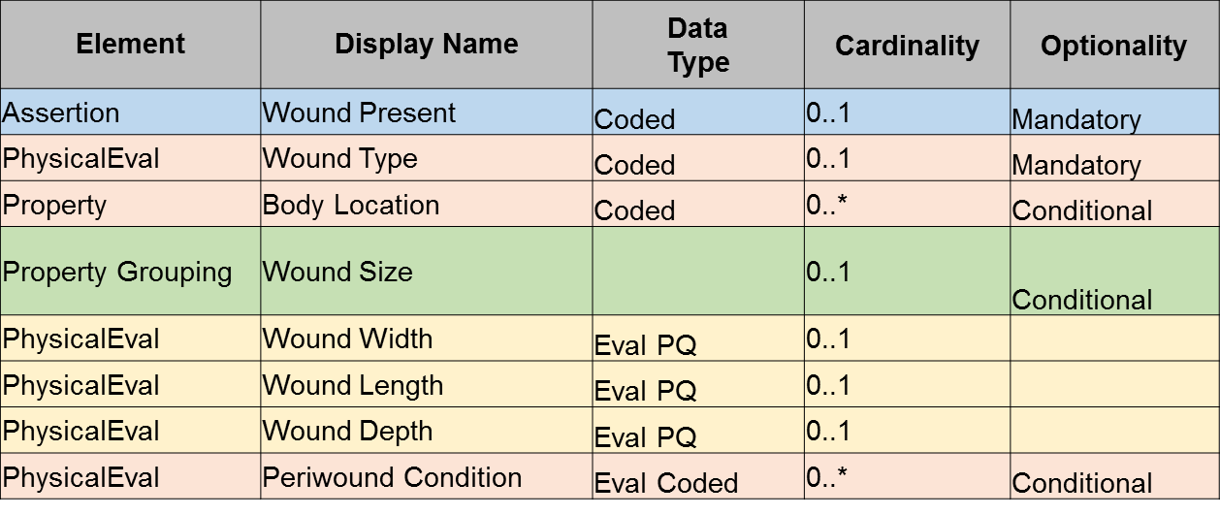

## Preliminary DCM Mind-Maps

The Skin-and-Wound assessment DCM work will continue into 2017Q2 and Q3.

The following are mind-map prototype DCMs for the Figure 4 Skin-and-Wound Assessment UML Requirements Model

* Figure 5 Notional BMM level-3 hierarchy to the Skin-Ulcer Assertion DCM
* Figure 6 Notional Evaluation-Result DCM for Skin-and-Wound Assessment
* Figure 7 Notional Evaluation-Result DCM for Skin-and-Wound Assessment (continued)

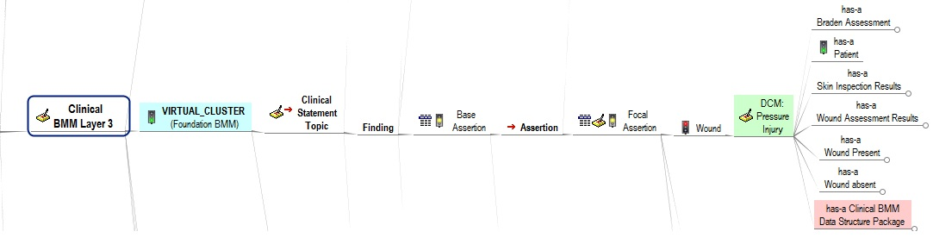

Figure 5 Notional BMM level-3 hierarchy to the Skin-Ulcer Assertion DCM

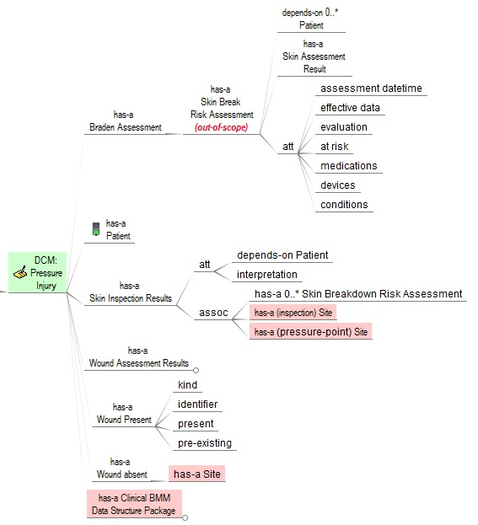

Figure 6 Notional Evaluation-Result DCM for Skin-and-Wound Assessment

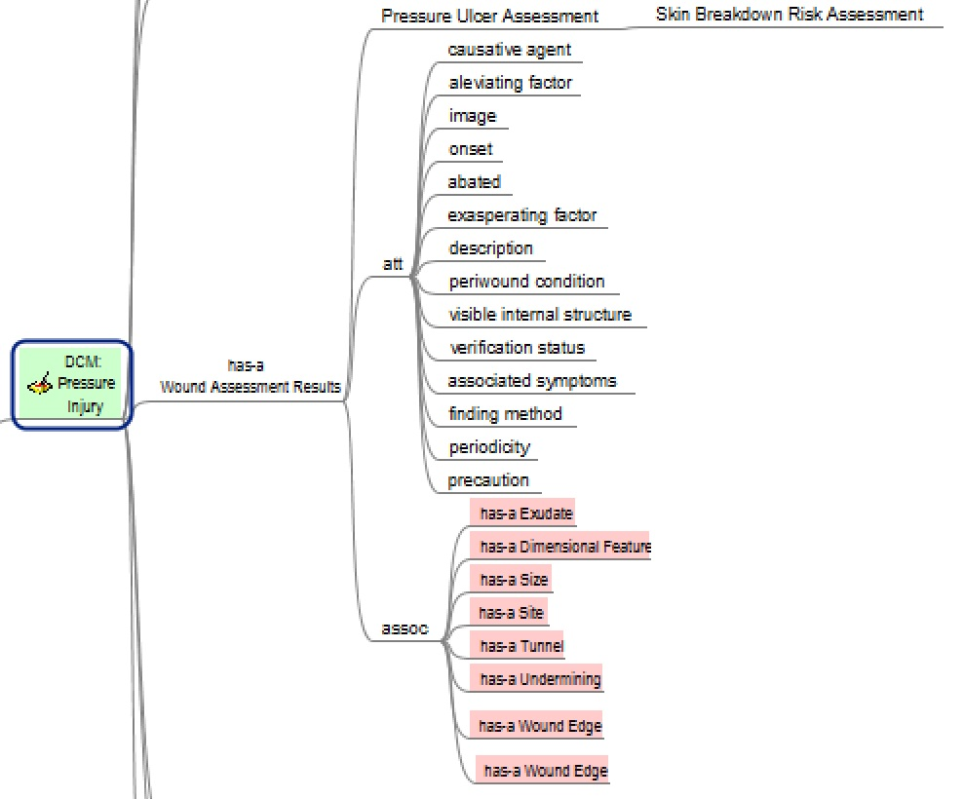

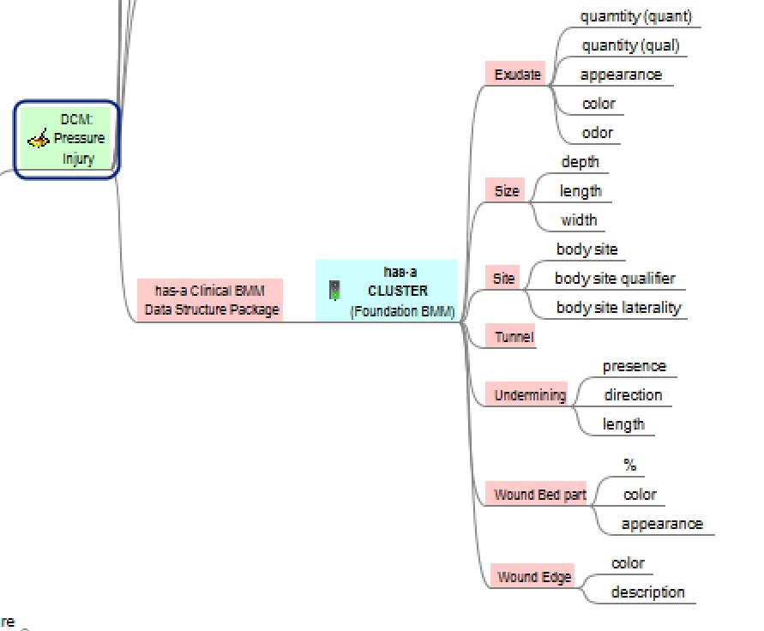

Figure 7 Notional Evaluation-Result DCM for Skin-and-Wound Assessment (continued)

|  |
| --- |
|  |

# Discussions (from CIMI workgroup e-mail)

1. **Gerard Freriks**: They call SNOMED a language. To me it is just a modern medical dictionary. Language is syntax; where, a dictionary adds phrases.
   1. **Richard Esmond**: I wouldn't consider the SNOMED Ontology a language, but I work with clinical-statement in the form of SNOMED Expression Language to communicate directly translated English clinical narrative. That might not be the phraseology I would choose if I was speaking to a room full of advanced degrees in the higher-arts of informatics. But if I was speaking to a room of IT decision-makers and nerdy physicians - then that is the language I would probably use. [Richard Esmond]

**Example**: The patients grandmother died of lung cancer.

{

243796009|Situation with explicit context|:

{

246090004|Associated finding| = 448993007|Carcinoma of lung|,

408731000|Temporal context| = 410513005|Past|,

408732007|Subject relationship context| = 113157001|Grandmother|,

408729009|Finding context| = 410515003|Known present|

}

}

* 1. **Gerard:** Yes, you can express that in a complex SNOMED code; but, you can only express what SNOMED allows. Most of the epistemological/context data can NEVER be expressed using SNOMED methods.
     1. **Example**: Patients ‘Grandmother died of lung cancer on 1-1-2111 at 13 pm as documented by XYZ at 14 PM on 2-1-2111; where, SNOMED can never replace all of CIMI’s structures.
  2. **Richard**: Agreed, when the scope is limited to the existing SNOMED Ontology much of the elements necessary for an information model that is sufficient to express the full context needed for a medical records platform. If you add the addition DL content of SOLOR (with LOINC), and then the SNOMED extensions that are intended to be authored at HSPC, then you likely get quite a bit closer to that goal.
     1. If someone wanted to, they could keep enhancing the SituationWithExplicitContext (SWEC) until everything necessary could be expressed in a clinical statement has the appropriate attributes and concepts necessary. But since it's unlikely that this would be preferable in any meaningful way to the strategies that CIMI is pursuing - I consider that a purely academic conversation.
     2. OpenEHR, ISO-13606 and CIMI have an approach that has important advantages over SNOMED Expression language when it comes time to Transform our logical definitions into something that can be implementable using IT architectures that are most prevalent within the healthcare community. SNOMED Expressions are relatively easy to store in a standard information model - they are just a single string - but they are very difficult to 'expose' for queries and indexing through anything like a relational database.
     3. So, while I use (and like) SNOMED Expressions throughout my own internal component pathways - and defend them for being useful. They wouldn't be a good strategy for serialization of clinical information in most cases.
     4. One thing that I am a BIG advocate of however... to use the SWEC architecture to 'guide and inform' the modeling practices in CIMI - whenever possible. It's now always possible for the very reasons you gave - IE, when, where, etc. - but when it covers an axis, it's nice to follow their lead.
  3. **Gerard**: What you present and what SNOMED allows is, what I call, the Swiss Army Knife method.
     1. The primary function of a terminology is to provide words, codes and coherent descriptions. And, nothing else.
     2. What you describe is extending the dictionary function to the structures for documentation function.
     3. I am a firm believer of the notion of autonomous models for each aspect of the Semantic Stack and I am of the opinion that mixing these functions will create problems.
     4. Coding systems, classifications/terminologies, are like words in a dictionary. What they describe is true in general. It is part of the Open World Assumption domain.
     5. Models (CIMI structures) collect what is true at a point in time and in a specific context; it is part of the Closed World Assumption domain.
     6. It is a mistake to mix both and will create problems for reasoners.
     7. What about the perceived need that clinicians have to use complex SNOMED codes? Users may be well served, in a specific context and for specific reasons, to use these complex SNOMED codes.
     8. But in CIMI models we need to express things in a way that does not overlap structures and coding systems. We must not enhance the Boundary Problem between structures and coding systems.
     9. This is what for quite a time was/is the CIMI set of principles. Therefore, we must be very cautious to that what SNOMED makes possible; where, CIMI, must be informed by SNOMED; and, we must reserve a place for our diversions from SNOMED as needed.
     10. So, yes, we agree for EHR-system technical-interfaces; where, CIMI is in the driving seat with its structures and its use of simple-concepts from SNOMED; but, clinical user interfaces are the domain of system-providers and their customers.

1. **Gerard**: I continue to have problems with terms like: assertion in the context of figure 3. What is the definition of the term ‘assertion’ and 'finding'?
   1. Definition of assertion [Noun] (plural assertions)
      1. The act of asserting, or that which is asserted; positive declaration or averment; affirmation; statement asserted; position advanced.
         1. You're a man of strong assertions!
      2. A statement or declaration which lacks support or evidence.
         1. That's just a bare assertion.
      3. Maintenance; vindication
         1. the assertion of one's rights or prerogatives
      4. (computing) A statement in a program asserting a condition expected to be true at a particular point, used in debugging.
      5. Is ‘assertion’ as you use it: 'the act of’, ‘ a 'positive declaration’, ‘affirmation’?
      6. Or is it ‘statement which lacks support’?
      7. Or the last one: 'statement in a program’?
         1. I’m of the opinion that any statement in a medical record is an assertion as a variant on Definition: Assertion: Statement about the condition of something. In the provision of health and care the patient, the subject of care.
   2. Definition of finding
      1. the act of one that finds b : find 2
      2. findings plural : small tools and supplies used by an artisan (as a dressmaker, jeweler, or shoemaker)
      3. a: the result of a judicial examination or inquiry, b : the results of an investigation —usually used in plural
      4. My definition if ‘finding’: results of an investigation; where, this means that ‘findings’ are the results obtained as observation about the system the subject of care (patient) is part of.
      5. Finding=Observation
2. **Bernd Blobel**: You might remember interoperability initiatives started by the German OMG Chapter in the nineties already. The resulting Interoperability Reference Architecture Model has been successfully applied in automated design and implementation of interoperability use cases of different countries. The approach is also fundamental for most of the HL7 security specifications. In 2015, ISO TC 215 decided to adopt that Interoperability Reference Architecture to its interoperability specification to automate harmonization processes and to avoid endless revision cycles. The specification has been integrated in the revision of ISO 13606. Other standards will follow. Attached I send you a papers as well as the related part of ISO 13606 describing the approach[3]. If there are any questions, please do not hesitate to contact me immediately.

# Commentary: IIM&T from a CQI/CDS/CQF Perspective

1. **Ken Kawamoto**: “CQF should be front-and-center given that clinical decision support and quality measurement are core reasons for the investment in health IT, and as the federal government through ONC and CMS have been investing in CQF to improve care quality and value.” HeD and CQF considered FHIM from the start, and it was reviewed in our modeling. The main issue we ran into with the FHIM was that it was never balloted as an HL7 standard, and we didn’t find commercial vendor interest, at that point, in supporting it. I see two competing considerations:
   * 1. We want “good models” we can actually use (EHR vendors such as Epic and Cerner will actually adopt and support)
     2. We want “balloted standards” that are actually good for patient safety and quality of care, from a model perspective.
   1. We have been heavily exploring CIMI based on “good model”. However, we’ve run into the reality that EHR vendors are wedded to “balloted standards”. And, we have seen that not balancing “good models” and “balloted standards” leads us to a point where we have an unused standard.
   2. CONCLUSION: The CQF community is committed to trying to see if a CIMI-based approach can work for CQF and for the EHR vendors to agree to CIMI/FHIM/SOLOR “good model” support. But if that conflicts, I would have to say “balloted standards” will likely outweigh “good models” alone.
   3. While I agree with not wanting to constrain us excessively to what currently exists, I think most implementers (including myself) need a solution that works with our EHR platform. In many of our cases, that means EHRs such as Epic and Cerner. I think we should make our best effort to arrive at a good model that also is supported by Epic, Cerner, and the like.
   4. I think practically speaking:
      1. Claude and others needs to be resourced to move CIMI-FHIM-SOLOR-CQF integration forward
      2. We need to crowd-source
2. **Keith Campbell**: But, For CQF to be relevant, we need to resolve the underlying issues that prevent the FHIR resources from being reproducibly applied, since CQF has a dependency on FHIR which lacks a solid foundation and there is no “international agreement” on a single coherent foundation for it (such as SOLOR) … I think we have to tackle the problem by moving forward with something that is "good for patient safety and quality of care, from a model perspective” and that provides the foundation necessary to resolve the interoperability problem, with the leap of faith that if we actually do a good job at it, Cerner and Epic will want to adopt it because of the value it provides to their consumers (providers, patients, etc.), or because their consumers will force the transition through market pressure.
3. **Claude Nanjo**: Our hope is that CQF will adopt FHIR profiles derived from CIMI archetypes developed through the collaboration of the FHIM team and the CDS and CQI WG at HL7. CIMI currently specifies two representation languages - ADL and AML - so by adopting FHIR profiles derived from CIMI archetypes, CQF would be fully aligned with the CIMI specification. CIMI is also using SOLOR as the underlying model of meaning for its archetypes - hence, future QICore FHIR profiles, the clinical quality FHIR profiles used by CQF, would leverage the same terminology bindings as those specified at the CIMI level since they will be generated from CIMI archetypes. Moreover, CQF can leverage the CIMI logical model in the definition of knowledge artifacts such as rules, order sets, and documentation templates. Thus, CQF is aligned with CIMI archetypes at both the DSS interface level but also in the definition of logic applied to this data.
4. **Ken Kawamoto**: I agree with Claude; but, one issue we have run into is with regard to how we support or do-not-support proprietary codes. It would of course make our lives a lot easier if everyone only used SOLOR codes, but as many data are currently in proprietary codes, getting accurate CDS or quality measurement often requires using value sets of proprietary codes, which do not always have a clear mapping to existing SNOMED codes, etc. We could of course ask for new SNOMED codes to be added, etc., but this introduces a delay in how fast we can actually meet an operational clinical need. So if we require SOLOR only, I think we need to come up with a feasible approach to address what to do when there are no clear SOLOR code mappings to existing data, even if we accept the additional work effort for mapping to SOLOR (which can be a tough sell within a single institution).
5. **Floyd Eisenberg**: I think that conceptually we have handled proprietary codes as a local issue that does require mapping. And, that by maintaining standard SOLOR we may be able to drive more standard interoperability. The problem is in the details. eCQMs continue to use 'interim' code systems but the Standards Committee Task Force did recommend ONC develop a roadmap and path to get standard code systems implemented. This may be the path.
6. **Ken Kawamoto**: I like the idea of strongly encouraging the use of standard terminologies like SOLOR but not making it excessively hard or impossible, if you have to deal with data that is not encoded in that format, and which have no clear mappings to SOLOR.

# References

**This quote seems applicable to CIMI’s quest-of achieving healthcare “computable semantic-interoperability.”**

*“It is not the critic who counts; not the man who points out how the strong man stumbles, or where the doer of deeds could have done them better. The credit belongs to the man who is actually in the arena, whose face is marred by dust and sweat and blood; who strives valiantly; who errs, who comes short again and again, because there is no effort without error and shortcoming; but who does actually strive to do the deeds; who knows great enthusiasms, the great devotions; who spends himself in a worthy cause; who at the best knows in the end the triumph of high*

*achievement, and who at the worst, if he fails, at least fails while daring greatly, so that his place*

*shall never be with those cold and timid souls who neither know victory nor defeat.”*

*[Theodore Roosevelt, Apr 23, 1910, Sorbonne, Paris, France]*

**Supporting Documents**

HL7 IIM&T Project Scope Statements <https://1drv.ms/f/s!AlkpZJej6nh_lIQOuPJcL2rf5BVoXQ>

IIM&T Technical Forum Summary <https://1drv.ms/w/s!AlkpZJej6nh_k9gyRVADgOvM5SlJkQ>

IIM&T Work Breakdown Structure <https://1drv.ms/f/s!AlkpZJej6nh_lKc00J3Kh2BTkopPnA>

IIM&T Briefing Slides <https://1drv.ms/p/s!AlkpZJej6nh_k9dE-b_DAO8HSNNT6Q>

IIM&T Newsletters <http://wiki.hl7.org/index.php?title=CIMI_Newsletters>

IIM&T Reports <https://1drv.ms/w/s!AlkpZJej6nh_k9dQ2qQnRuQM8gbu8A>

CIMI web-site <https://www.opencimi.org>

* CIMI BMM Browser <http://models.opencimi.org/cimi_doc/>
* CIMI Architype-Model Browser <https://www.opencimi.org/model-browser>

CIMI Wiki <http://wiki.hl7.org/index.php?title=Clinical_Information_Modeling_Initiative_Work_Group>

* CIMI Minutes <http://wiki.hl7.org/index.php?title=CIMI_Minutes>
* CIMI Ballot Materials (unofficial) <https://drive.google.com/drive/folders/0ByrVwEEPQjMyazNLMUNFZ2YtNk0>
* CIMI Modeling, Architecture, Methodology and Style Guides <http://wiki.hl7.org/index.php?title=CIMI_Modeling,_Architecture,_Methodology_and_Style_Guides>
* CIMI Practitioners Guide to HIT Interoperability <http://wiki.hl7.org/index.php?title=CIMI_Practitioners%27_Guide>

US CORE Wiki <https://oncprojectracking.healthit.gov/wiki/display/TechLabSC/DAF+Home>

Skin and Wound Assessment Pilot Wiki <http://wiki.hl7.org/index.php?title=PC_CIMI_Proof_of_Concept>

SNOMED CT: <http://ihtsdo.org/index.html>

* Expression Constraint Guide <https://confluence.ihtsdotools.org/display/DOCECL/Expression+Constraint+Language+-+Specification+and+Guide>

HL7 ballot desktop (official) <http://www.hl7.org/ctl.cfm?action=ballots.home&ballot_cycle_id=543>

review HL7 ballot materials from

<http://www.hl7.org/documentcenter/public/ballots/2017MAY/downloads/HL7_XPARADIGM_CIMI_LM_R1_I1_2017MAY.zip>.

**Questions?**

Contact Facilitators at:

[Nona.G.Hall.civ@mail.mil](mailto:Nona.G.Hall.civ@mail.mil)

[Stephen.Hufnagel@ApprioInc.com](mailto:Stephen.Hufnagel@ApprioInc.com)

Some networks block the use of clickable links; where,

You must copy the link into a browser to access the content.

If links don’t work on a Government Network or VPN, try accessing them directly (without VPN)

# Acronyms

*“When I use a word, it means just what I choose it to mean — neither more nor less.” [Alice in Wonderland, 1892, Lewis Carroll]*

|  |  |  |  |
| --- | --- | --- | --- |
| BMM | CIMI Basic Meta Model components | ISAAC | VA tool for SOLOR |
| CEM | Intermountain Clinical Element Models | ISO | International Standards Organization |
| CIMI | HL7 Clinical Information Model Initiative | JIF | VA/DOD Joint Incentive Fund |
| CLIM | HL7 Common (Clinical) Logical Information Model | KNART | CDS Knowledge Artifact |
| CQI | HL7 Clinical Quality Information | LOINC | Logical Observation Identifiers Names and Codes |
| CQF | HL7 Clinical Quality Framework | MDHT | Model Driven Health Tools |
| DAF | ONC Data Access Framework | MDMI | Model Driven Message Interoperability |
| DCM | Detailed Clinical Model | ONC/OST | US Office of the Natl. Coordinator / Office of Science and Tech. |
| eCQM | CQI Electronic Clinical Quality Measure | PMP | Program Management Plan |
| STU | HL7 Standard for Trial Use | PSS | Project Scope Statement |
| EDW | Electronic Data Warehouse | QUICK | CQI Quality Information and Clinical Knowledge logical model. |
| FDA | US Federal Drug Agency | RXNorm | US National Library of Medicine naming system for drugs |
| FHA | US Federal Health Architecture | SIGG | Standards Interoperability Guide Generator |
| FHIM | US Federal Health Information Model | SOLOR | SNOMED extension for LOINC & RXNorm |
| FHIR | HL7 Fast Health Information Resource | TLC | ONC/OST Technical Learning Center |
| HIEA | DoD VA IPO Health Interoperability Exchange Alliance | VA | US Veterans Administration |
| HcDir | ONC-FHA Provider Healthcare Directory. | VCS | Version Control System for collaboration |
| IPO | US DoD and VA Interagency Program Office | VSAC | NLM Value Set Authority |

|  |
| --- |
|  |

# Attachment: HL7 IIM&T Project Summary

Steve Hufnagel, Editor

Based-on content-from

Keith Campbell Stan Huff, Julia Skapik, Steve Wagner,

Galen Mulrooney, Richard Esmond, Sean Muir, Dave Carlson, Ken Lord,

Dan Monford, Rob McClure, Susan Matney, Jay Lyle, Claude Nanjo, Patrick Langford, Joey Coyle,

Floyd Eisenberg, Walter Sujansky, Ken Kawamoto, Thomas Beale, Gerard Freriks, William Goossen, Deniz Akkor,

## Preface

This attachment will evolve into the CIMI Practitioners Guide for non-technical stakeholders. It also complements the CIMI May Ballot’s Architecture and Style Guides. This overview harvests content from the August IIM&T Investigative-Study Preliminary-Report and Technical-Forum, September 2016 IIM&T Investigative-Study Final-Report, 2016Q4 and 2017Q1 Newsletters. Suggestions for improvement are always appreciated.

## Abstract

Shared clinical-information requires computable semantic-interoperability for clinical decision support and population-based reasoning. SOLOR is the foundation of the collaborative IIM&T[4] model-driven-development tool-enforced methodology to construct consistent, traceable and re-usable HL7 FHIR, CDA, V2 and V3 messages plus JSON APIs, NIEM etc. specifications, implementation guides, implementation-artifacts and component-based architectural building-blocks, such as HSPC[5] SMART[6]. The evolving IIM&T methodologies, technologies and federated governance[7] are the key-facets to efficient-and-effective shared-data and plug-and-play Healthcare Information Technology (**HIT**) interoperability. The Federal Health Information Model (**FHIM**), Clinical Quality Initiative (**CQI**), Clinical Decision Support (**CDS**) and Clinical Information Model (**CIMI**) teams are refactoring, harmonizing, and integrating the FHIM Domain Classes, Clinical Quality Framework (**CQF**) and CIMI Logical Information Models (**LIM**[8]) for consistent and traceable HIT Platform-Specific Model (**PSM**s[9]) interoperable-implementation artifacts, such as CDA and FHIR Extensions and Profiles.

The CIMI-sponsored HL7 IIM&T project is working in alignment with other HL7 workgroups, The Open Group Healthcare Forum[10] and HSPC with a computable semantic-interoperability goal; and with, an objective to minimize the need for traditional-and-expensive Extraction, Transformation and Load (**ETL**) mappings and tools. CIMI standardized artifacts are collectively referred to as the HL7 Common (Clinical) Logical Information Model (**CLIM**); where, CLIM is a package of CIMI architectural-framework harmonized LIMs (e.g., SOLOR, FHIM, QUICK, DCM, eCQM, KNART and CDA, V2, V3, FHIR (US CORE, QI Core, Profiles and Extensions), etc.) and Platform-Specific Models (**PSM**s), balloted at HL7 and ISO. Traditional LIM-and-PSM development-strategies are typically incomplete and inconsistent; where, the Figure 9 IIM&T Model Driven Development Strategy and the subsequent article address this problem with the IIM&T Architectural Framework including the basic CIMI Basic Meta Model (BMM), Architypes and Patterns, DCMs, Principles, Methodology and Technologies for producing implementation specifications and artifacts.

Clinical knowledge content is a critical part of modern healthcare platforms, therefore, the needs of managing (authoring, reviewing and maintaining) clinical content in a deterministic-and-accountable way is crucial. Figure 9 IIM&T Model Driven Development Strategy summarizes the IIM&T requisite methodology-and-technologies including FHIM, CQF, KNART, LEGO and DCM clinical-content structures, SOLOR environment of Termlogic terminology-editor and Ontologic terminology-server, STAMP configuration management versioning and SIGG (MDHT, MDMI) tools, which use the CIMI Architectural Framework of reference models, principles and methodology to better achieve plug-and-play HIT interoperability.

**Table of Contents**

CIMI-Sponsored HL7 IIM&T Project #1316 1

“*Integration of Information Models and Tools*” 1

CONTENTS 1

EVENTS 1

Tuesdays 1

Wednesdays 1

Fridays 1

Introduction 1

Executive Summary 2

Technical Overview 2

Plans 3

Recent Activities and Milestones 3

2017Q1 Focus: FHIM, CQF and CIMI Harmonization 3

2017Q1 Collaboration Pilot-Projects* 4

Feature Article: SOLOR Foundation of IIM&T Project 5

SOLOR 5

LEGO 5

Termspace – Terminology Editing 6

Ontoserver – Terminology Server 6

VSAC 6

STAMP Versioning 7

Feature Article: Skin-and-Wound Assessment Pilot 7

Background 7

Milestones and Plans 8

User Story 9

Requirements 10

Preliminary DCM Mind-Maps 11

Discussions (from CIMI workgroup e-mail) 14

Commentary: IIM&T from a CQI/CDS/CQF Perspective 16

References 17

Acronyms 18

Attachment: HL7 IIM&T Project Summary 19

Preface 19

Abstract 19

Background 21

Strategy 24

Milestones 25

2017Q1 Collaboration Pilot-Projects 25

Architectural Framework 28

Methodology 29

FHIM 31

CQI/CDS/CQF 31

CIMI 31

DCMs 32

openEHR 32

ISO 33

SOLOR 34

LEGO 35

Termspace – Terminology Editing 35

Ontoserver – Terminology Server 35

VSAC 35

STAMP Versioning 36

SMART 36

SIGG (MDHT, MDMI) 36

Conclusion 37

Acknowledgement 37

Acronyms and Links 38

Acronym Cross-Reference Index 39

**Table of Figures**

Figure 1: IIM&T 2017Q1 Status and Plan 3

Figure 2: SOLOR with SNOMED extensions solve LOINC and RXNorm inconsistencies 5

Figure 3 Skin and Wound Assessment Approach 8

Figure 4 Skin-and-Wound Assessment UML Requirements Model 10

Figure 5 Notional BMM level-3 hierarchy to the Skin-Ulcer Assertion DCM 11

Figure 6 Notional Evaluation-Result DCM for Skin-and-Wound Assessment 12

Figure 7 Notional Evaluation-Result DCM for Skin-and-Wound Assessment (continued) 13

Figure 8 Problem: Skyscraper Analogy 23

Figure 9 IIM&T Model Driven Development Strategy 24

Figure 10 Health IT Goal: Computable Semantic-Interoperability 25

Figure 11: IIM&T Roadmap 26

Figure 12: IIM&T 2017Q1 Status and Plan 27

Figure 13 CIMI Architectural Framework 28

Figure 14 CIMI Methodology 29

Figure 15: SOLOR with SNOMED extensions solve LOINC and RXNorm inconsistencies 34

## Background



* **Clinical Goal:** is to help people live the healthiest lives possible by enabling a “Learning Health System” supporting areas such as, but not limited to, Precision Medicine, Clinical Decision Support, Genomics, Research, etc.
* **Problem:** Today’s systems do not capture the same information in the same way, and therefore we cannot easily share-or-merge information across disparate-systems to create a harmonized, operational picture of a patient across multiple care locations and contexts.
* **Proposed Solution:** Capitalize on the inroads made with the exchange of data, standards and standards adoption, and, through this effort, bring back a focus to the data in-order-to bolster FHIR, CDA and NIEM clinical content and consistency, thereby reducing implementation variability.
* **IT Objective:** Make appropriate data available when it is needed, where it is needed and how it is needed.
* Models need to be accepted as the foundation of interoperability
* Pursue the Integration/harmonization of CLIM, as-a package of SOLOR, FHIM, CIMI, CQF as the Enabling Foundation to jump start initiatives
* Integrate tooling to support models to extend the utility of these assets
* Use models and tools to generate standards and implementation artifacts.
* Advance in constructive steps through pilots and agile developments
* **Approach:** Demonstrate the Viability of Integration Via Pilots (see listing under “Milestones and Projects”)
* Identify the Project with willing parties that will implement the outputs for the Project
* Identify the data elements needed to support the project
* Identify the FHIM classes that support the data elements
* Make the detailed CIMI models utilizing SOLOR for the source of terminology / vocabulary
* Approve the model
* Place model in a registry that is publicly available
* Make the application via use of FHIR Profiles
* Test the application for compliance with the model and standards
* Put the application in production use & evaluate its value
* General: Make people available; EHR behind that also available
* Parallel Activities: Install a SOLOR Terminology Server; Need to harmonize models & tools
* **Key to Success: Leverage and grow our strong SME base!**

**Methodology:** Using Model Driven Development, leverage CIMI principles (e.g., a clean separation of clinical model semantics using SNOMED, LOINC and RxNORM), CIMI reference models, and tools, we can produce semantically-consistent data.

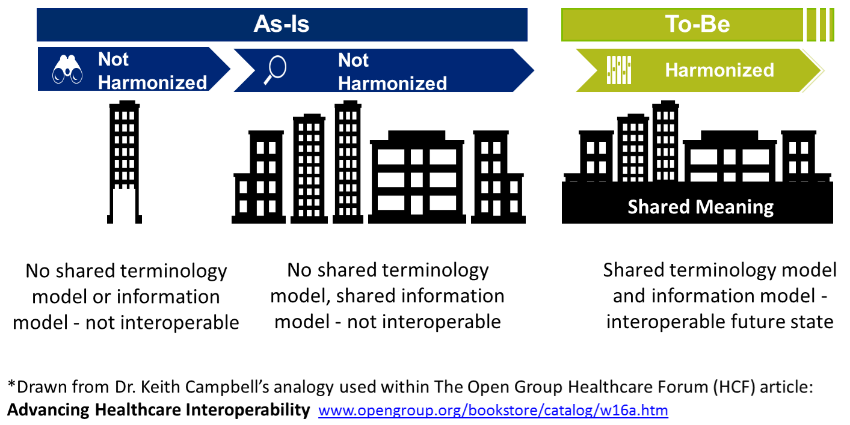

Figure 8 Problem: Skyscraper Analogy

In Figure 8 Problem: Skyscraper Analogy

* **As is**: no shared terminology content (floor 1), no shared information models (floor 2), then they are building from the 3rd floor up. No shared value from the 3rd floor up.
* **Future State**: shared terminology content (floor 1), shared information models (floor 2), sharable value built on floors above.
* **In a perfect world** the following would be done concurrently and with close collaboration
* Recommended Solution Part 1: We integrate SOLOR into FHIM
  + Concurrently, resolving SOLAR gaps
* Recommended Solution Part 2: We integrate CIMI, FHIM and CQF
* Recommended Solution Part 3: We follow Agile refinement cycles through pilots and implementations
* Recommended Solution Part : We develop adequate documentation, test cases, fixtures and supporting resources

In the real world, we are asking:

* the Federal Partners to provide resources to make efficient and effective progress in the near, mid and long term.
* the Federal Partners to work together to deliver—in an ongoing way—a single integrated terminology system (SOLOR), that meets all US regulatory requirements, while simplifying implementation for developers.
* the FHA to facilitate Federal Partner governance and configuration management of this work
* This ONC OTS to endorse this initiative and facility resources
* We are asking the IPO to provide coordination and facilitation
* We are asking HL7 to facilitate
  + international, commercial and academic peer review and
  + ballot governance and configuration management.
  + Coordination of an ISO ballot (this will be several years from now)
* Analogy of the Challenge: Today’s efforts occur as if we’re always trying to build the ultimate skyscraper, starting on the 3rd Floor.
* Inconsistencies exist/become extended producing transformational (mapping) efforts = models, models everywhere
* The problem is that today’s healthcare systems do not capture information and its context consistently, and consequently, they cannot easily share-or-merge information from different sources to create a computable operational-picture (aka longitudinal patient-records, care plans, clinical knowledge and other shared healthcare information across time, multiple care locations and differing contexts).
* If continued and unchecked, even the best of implementation accelerators, like FHIR with its extensions and profiles, allow far too much implementation variation; where, each project often creates, from scratch, yet, another information model, e.g. through a mapping exercise.
* The missed opportunity is to leverage a shared logical Reference Information Model minimizing the duplicative-work, avoiding inconsistencies and avoiding the necessity to engage these SMEs, these resources and our larger community. This is the “models, models everywhere phenomenon”. As an example,
  + Standards, in general, use different formats and rules for ‘simple’ things like: name, address, dates. Resulting in EHR-systems that after decades cannot uniformly exchange this ‘simple’ ubiquitous data; let alone ‘complex’ clinical health data.
  + the HL7 EHR Interoperability workgroup, in its analysis “Record Entry Lifecycle Event Metadata using FHIR,” found substantial provenance (who, what, when, where and how) inconsistencies among FHIR resources .
    - http://wiki.hl7.org/index.php?title=EHR_Interoperability_WG
  + The SOLOR/LEGO team found FHIR tries to define things such as attributes for anatomy, that are not based on a particular model of anatomy, and thus you get semantic overlap, with the burden of reconciliation, which may not even be possible, if left to the end user.

## Strategy

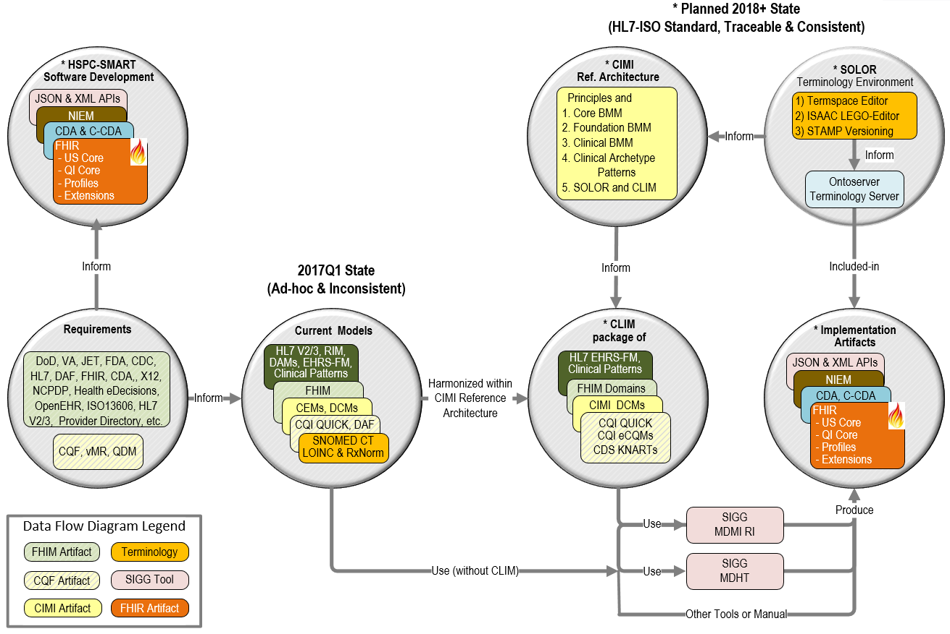

Figure 9 IIM&T Model Driven Development Strategy

Figure 9 IIM&T Model Driven Development Strategy supports vendors, developers and implementers; where, the benefit of having the FHIR extension-and-profile development-process contained in one easy-to-use model-driven-development tool, such as open-source SIGG, empowers clinicians and analysts to maintain clear, complete, concise, correct, consistent and traceable standards & implementation artifacts, which are easy-to maintain-and-use by clinicians, analysts, Federal Agencies and their staff, contractors, partners, venders and integrators. Commercial tools, such as Sparx Enterprise Architect, No Magic MagicDraw, RSA Software Architect, Troux Architect, etc. can be scripted with comparable open-source SIGG functionality.



Figure 10 Health IT Goal: Computable Semantic-Interoperability

## Milestones

* 2010-05 – CIMI became an IHTSDO workgroup
* 2016-01 – CIMI became an HL7 workgroup
* 2016 Jan-Sep – CIMI-sponsored HL7 IIM&T investigative study
* Final Report: https://1drv.ms/w/s!AlkpZJej6nh_k9dlCRdJv51X0tFp9A
* 2016-08 ONC, FHA and IPO co-sponsored IIM&T Technical Forum
* 2016-09 CIMI-sponsored HL7 IIM&T Project #1316
* HL7 Project Scope Statement: https://1drv.ms/w/s!AlkpZJej6nh_k_1Hi-yFatfOvK8-gQ
* 2016-11 FHA Managing Board - current status and resourcing-recommendations provided
* 2017-01 HL7 comments-only ballot - CIMI Architectural Framework and BMM
* 2017-05 HL7 Informative Standard - CIMI Architectural Framework, BMM, Foundational Architypes, Detailed Clinical Models
* 2017-09 HL7 Standard for Trial Use (STU)
* 2018-09 HL7 Standard for Trial Use (STU)
* 2019-09 HL7 Normative Standard
* **NOTES**:
* Added domains can add-to the BMM.
* Added use-cases can add-to the Reference Architypes, DCMs and FHIR profiles and extensions.

## 2017Q1 Collaboration Pilot-Projects

Where, #1, #2, #3 indicate May-2017 Ballot inclusion-priority:

* FHIM integration of CIMI Clinical BMM & Archetypes (Patterns) #1 [Galen Mulrooney]
* US Core / QI Core integration of CIMI BMM & Archetypes (Patterns) #1 [Claude Nanjo]
* Patient Care Project 1253 "CIMI Clinical Model Proof of Concept" (Skin Wound Assessment)
* http://www.hl7.org/special/Committees/projman/searchableProjectIndex.cfm?action=edit&ProjectNumber=1253
* content #1 [Jay Lyle and Susan Matney]
* Terminology/SNOMED Expressions #1 [Jay Lyle and Susan Matney]
* SOLOR (SNOMED extension including LOINC and RxNorm) #1 [Keith Campbell and Susan Matney]
* Clinical Decision Support Workgroup's Quality measures #2 [Ken Kawamoto and Claude Nanjo]
* Refine PROCEDURE and CONTEXT based on Pilots #1 (Galen Mulrooney and Claude Nanjo)
* Pediatric Bilirubin Management CDS #2, needs code generation library [Ken Kawamoto and Claude Nanjo]
* Zika measure #3 [Ken Kawamoto and Claude Nanjo]
* Immunization Management EHR Functional Model Profile #3 (Steve Hufnagel and Gary Dickinson)
* Family Planning Annual Report (FPAR) – HSPC pilot with ACOG #3 [Stan Huff, Susan Matney]
* Device interfaces MDEpiNet. #3 [Julia Skapik]
* FHIR JET (Joint Exploratory Team) #3 Nona Hall, IPO, VA, DoD

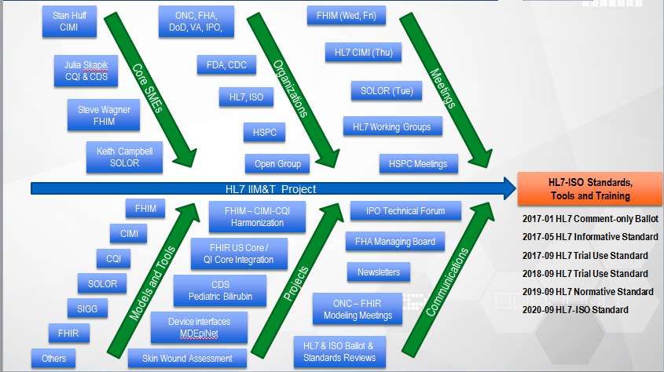

Figure 11: IIM&T Roadmap

The Roadmap shows the facets needed for the successful execution of the HL7 Integration of Information Models and Tools (IIM&T) Project.

* The “Core Subject Matter Experts (SMEs)” provide leadership and governance.
* The “Organizations” are the stakeholders and proponents
* The “Meetings” help to keep stakeholders informed and engaged on an ongoing basis
* The “Models and Tools” are being harmonized to produce clear, complete, concise, correct, consistent, traceable and easy-to-maintain standards and FHIR-CDA-NIEM implementation artifacts for Federal Agencies and their partners, venders and integrators
* The “Projects” are the proving-ground to independently verify and validate the IIM&T methodologies and technologies.
* The “Communications” are the essential outreach to evangelize IIM&T products and processes.



Figure 12: IIM&T 2017Q1 Status and Plan

The Integration of Information Models and Tools (IIM&T) project was successfully formed, defining essential requirements, specifications and principles as an Architectural Framework, aka Reference Architecture, of layered-models, to enable the production of clear, complete, concise, correct, consistent, traceable and easy-to-maintain standards and FHIR-CDA-NIEM implementation artifacts developed for Federal Agencies and their partners, venders and integrators; where in 2016,

* CIMI transitioned to being an HL7 workgroup in Jan 2016, after having been an IHTSDO workgroup since 2010.
* A CIMI-sponsored investigative-study was conducted from Jan thru Sept 2016; where, the investigative-study final-report and draft IIM&T Project Scope Statement (PSS) were delivered at the Sep 2016 HL7 Workgroup meeting for peer-review.
* ONC, FHA and IPO co-sponsored a two-day Health Interoperability and Exchange Alliance (HIEA) Technical Forum in Aug 2016 to share the investigative-study results among IIM&T stakeholders-and-proponents and to coalesce issues, recommendations and a way-forward roadmap into a final-report and HL7 PSS.
* FHA Managing Board briefings were provided in October and November to obtain Federal Partner concurrence with The HL7 PSS.
* CIMI Basic Meta Model (BMM) specifications were formulated for the January comments-only ballot to get peer-review. These were based on OpenEHR and ISO13606 BMM; but, were adapted to be more stable, flexible and easier-to-use.

In 2017Q1 the Pilot-project were used to drive refinement:

* HL7 Project Scope Statement was peer-reviewed and updated in-accordance-with HL7 co-sponsoring workgroups feedback.
* HL7 comments-only ballot (Jan), which included the CIMI Basic Meta Model specifications
* FHIM was harmonized with CIMI BMM
* QI Quick was harmonized with CIMI BMM
* Skin-Wound Assessment-Models

During the rest of 2017 Pilot-projects drive refinement:

* HL7 Informative ballot (May)
  + Architectural Framework
  + Skin Wound DCMs
* HL7 Trial Use Standard (Sep)
  + Clinical Statements
  + Procedures
  + Orders
  + FHIR US Core and QI Core
* FHIR Profiles and Extensions

2018-2020 Pilot-projects drive refinement

* 2018 HL7 Standard for Trial Use Update
* 2019 HL7 Normative Standard
* 2020 HL7-ISO Standard
* Integrated Tools refinement
* Practitioners’ Guide updates
* Comprehensive Training Materials updates
* Reference FHIR, CDA, NIEM extensions, profiles, test and implementation artifacts refined and updated

## Architectural Framework

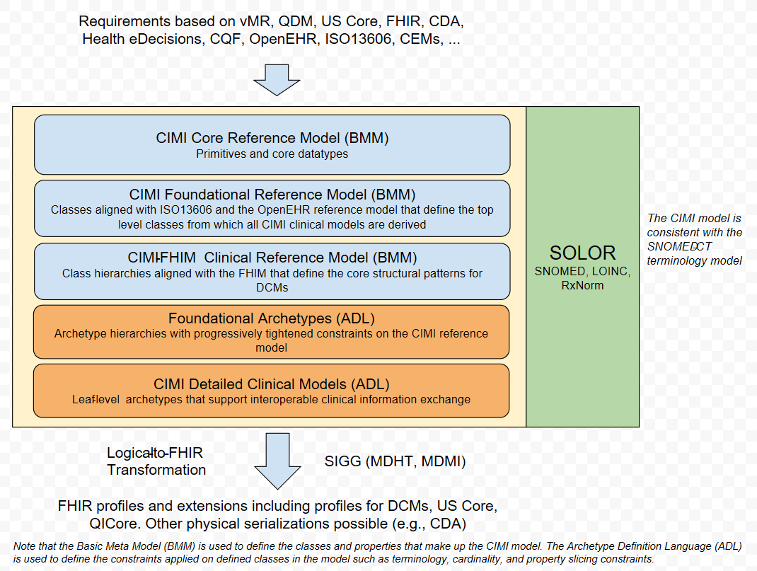

Figure 13 CIMI Architectural Framework

<https://docs.google.com/drawings/d/1cw_eZjREOJlVVptPbDoNwkqAyD08ZTVRuwuA9VVWRRU/edit>

The CIMI Reference Model is expressed using the OpenEHR Basic Metamodel (**BMM**) Language. The archetype layers are expressed using the OpenEHR Archetype Definition Language (**ADL**). While reference model modules define classes, attributes, and class hierarchies, the archetype layers only specify progressive constraints on the reference model but do not introduce new classes, attributes, and class-class relationships.

1. The CIMI **Core Reference Model** provides the core granularity of the CIMI model and introduces its top-level classes such as the DATA_VALUE class and the LOCATABLE class. This reference layer module defines the CIMI primitive types and core data types.
2. The CIMI **Foundational Reference Model** is closely aligned to ISO13606 and the OpenEHR Core Reference Model. It defines foundational CIMI clinical documents and clinical record patterns. It also introduces the PARTY, ROLE, and PARTY_RELATIONSHIP patterns and defines the top-level CLUSTER class for complex CIMI type hierarchies. CQI Knowledge Artifacts may also leverage this layer.
3. The **CIMI Clinical Reference Model** consists of the classes derived from existing CIMI archetypes, the FHIM, QUICK, vMR, and QDM. This layer defines the set of *'schematic anchors'* (to borrow Richard Esmond's term) or core reference model patterns from which all CIMI archetype hierarchies and ultimately Detailed Clinical Models (DCMs) derive. Requirements for this layer come from FHIM, vMR, QDM, QUICK, FHIR US Core, SDC, etc...
   1. The goal is to define the reference models with low FHIR transformation costs where feasible noting that we will inherently have some divergence due to the different requirements underlying both models.
   2. Galen points out that, FHIM’s expressivity will not carry over to CIMI DCMs given the models' different requirements (e.g., FHIM includes finance and accounting).
4. **The CIMI Foundational Archetypes** define the top-level constraints on the CIMI Reference Model. These typically consist of attribute formal documentation and high level attribute semantic and value set bindings. Archetypes at this layer will provide the foundational requirements for future US Core and QI Core profiles. Future pilots will explore the generation of US Core and QI Core archetypes from these CIMI archetypes.
5. The **CIMI Detailed Clinical Model Layer** represents the set of leaf-level constraining profiles on the foundational archetypes to create families of archetypes that only vary in their finest terminology bindings and cardinality constraints. This layer is intended to support clinical interoperability through an unambiguous specification of model constraints for information exchange, information retrieval, and data processing.

From layers 1-5, we define the set of transformations (e.g., SIGG (MDHT, MDMI)) to generate the corresponding FHIR profiles including the US Core and QI Core profile sets. Note that FHIR profiles can be generated from the various levels of the archetype hierarchy depending on requirements. The lower down in the hierarchy, the more prescriptive the profile is in terms of constraints. Much like ADL Archetypes, FHIR profiles can be layered.

## Methodology



Figure 14 CIMI Methodology

Following Figure 14 CIMI Methodology, software (**SW**) project should generally follow some combination of these numbered steps and use the lettered artifacts; where, the heavy arrows are process flows and the light lines resource flows; and where the colored boxes represent governance scope:

* Path 1 7 8 represents the ideal case; where, reusable FHIR-based components are available.
* Path 1 2 3 4 7 8 is when new requirements are met locally; but, HL7 Items A-C are not updated.
* Path 1 2 3 4 5 6 7 8 is when new requirements are met locally; and, HL7 Items A-C are updated.
* Steps 1 2 3 4 are done by independent organizations
* Step 5, involving A & B is managed by the HL7 CIMI workgroup
* Step 6, involving C & D is managed by the HL7 FHIR Managing Board.
* Step 9 is periodically done by HL7, to configuration manage, version control, publish and standardize HL7 Items A-C.

Following Figure 14 CIMI Methodology, the numbered boxes mean:

1. Do Business and FHIM Analysis to determine system requirement-specifications and conformance criteria (process 1); where, EHRS-FM might be used; because, it is traceable to CLIM (FHIM) and CLIM will be traceable to FHIR.
2. Maintain the FHIM, CIMI, CQF, etc. models (process 2) to meet the requirements; where, these models may be updated and bound to SOLOR. This work can be done with an UML tool or the OpenEHR ADL workbench.
3. Maintain SOLOR (SNOMED with extensions for LOINC and RxNorm shown as process 3). If appropriate SOLOR concepts which do not exist, can be added using the IHTSDO workbench with ISAAC plugin. Processes 2 and 3 are closely related and may iterate back and forth or may be done simultaneously.
4. Use SIGG (MDHT, MDMI) to generate the needed implementation artifacts (e.g., FHIR structure definitions for profiles or extensions, CDA or NIEM IEPD specifications can also be done).
5. Governance involves change control, configuration management and version control; where, CLIM governance is generally federated. That is, local development organizations govern their own artifacts and may wish to provide versions to HL7. Appropriate HL7 workgroups govern HL7 artifacts and ballots.
6. Similarly, FHIR governance is generally federated; where, local development organizations govern their own artifacts and may wish to provide versions to HL7. At HL7, FHIR-compliant reusable-artifacts are governed by the FHIR workgroup.
7. Develop software components are generally done by commercial, government and academic organizations and their contractors. HL7 provides artifacts, documentation and training to empower these efforts.
8. Test-and-use software components is generally done by commercial, government and academic organizations and their contractors.
9. Periodically, CIMI and FHIM artifacts are balloted as HL7 and/or ISO standard, which include the set of clinical domain information models (e.g., FHIM covers 30+ domains), CIMI DCMs with SOLAR derived terminology value-sets. Having standard requirements-specification conformance criteria traceable to FHIR implementation artifacts can maximize efficiency and effectivity of multi-enterprise clinical-interoperability. These tool-based standardized clinical interoperability artifacts can be augmented with business, service and resource requirements-specifications conformance-criteria models and implementation artifacts. HL7 and its workgroups have identified best-practice principles and tools supporting its clinical-artifacts, which can provide standardized approaches for government, industry and academic organizations to adopt, train and use. These standard use-cases, conformance criteria models and implementation artifacts can be used and maintained within an HL7 Service Aware Interoperability Framework (SAIF) and Enterprise Compliance and Conformance Framework (SAIF) to support specific business use-cases, process models, acquisitions and/or developments.

**Figure 9 IIM&T** Model Driven Development Strategy supports vendors, developers and implementers; where, the benefit of having the FHIR extension-and-profile development-process contained in one easy-to-use model-driven-development tool, such as open-source SIGG, empowers clinicians and analysts to maintain clear, complete, concise, correct, consistent and traceable standards & implementation artifacts, which are easy-to maintain-and-use by clinicians, analysts, Federal Agencies and their staff, contractors, partners, venders and integrators. Commercial tools, such as Sparx Enterprise Architect, No Magic MagicDraw, RSA Software Architect, Troux Architect, etc. can be scripted with comparable open-source SIGG functionality.

## FHIM

The Federal Health Information Model (**FHIM**, see [www.fhims.org](http://www.fhims.org)) is a healthcare logical information model; where, a shared information model is needed to specify Electronic Medical Records, (**EMR**s), just like a blue print is needed to build a building; where, FHIM is organized into 30+ healthcare domains. Each healthcare domain is modeled as a UML package. Examples of domains would be allergies, surgery, or dentistry. FHIM started from the VHA Health Information Model (VHIM) (now the VIM). The VHIM was many years in the making and has over ten thousand hours of design work invested in it. This is why it was chosen as a basis for the FHIM, which has continued that evolution since 2010. Although sponsored by Federal agencies, the FHIM includes universal/international healthcare requirements, classes/data modules and vocabulary/data dictionary and terminology value-set bindings. FHIM is compatible with SIGG and is being harmonized with CIMI and SOLOR.

## CQI/CDS/CQF

Clinical Quality Framework (**CQF**, see <http://wiki.siframework.org/Clinical+Quality+Framework+Initiative>) is front-and-center given that clinical decision support (**CDS**, see <http://www.hl7.org/special/committees/dss/index.cfm>) and Clinical Quality Initiative’s (**CQI**, see <http://www.hl7.org/Special/committees/cqi/overview.cfm> ) quality measurement are core reasons for the investment in health IT. Healthcare evaluation Data (HeD) and CQF consider HL7/ISO balloted FHIM-CIMI models essential to commercial vendor interest and which is good for patient safety and quality of care.

What has become clear is the need for a formal logical model, intuitive that can be referenced in evidence-based clinical quality knowledge artefacts, useable in both rules engines and for clinical analytics. This logical model must provide the common ‘source-of-truth’ for both clinical information serving as input and output to clinical decision support systems and for the knowledge artifacts that act on this information. While FHIR provides standard message syntax for clinical resources and an API to manage such resources, FHIR alone cannot act as such a source of truth. A single FHIR resource can be profiled in many, potentially inconsistent, ways. Hence, we argue that the formal and explicit CIMI architectural framework, methodology and technologies are needed to define formal requirements and constraints, which are then translated into FHIR profiles definitions.

Clinical Decision Support artifacts should be decoupled from the underlying physical representation of clinical data. This allows for more stable and robust rules that can apply to other physical representation of clinical data such as proprietary formats or other HL7 standard implementation formats. In order to act as an international physical-message syntax, FHIR cannot be closely coupled to any particular terminology or ontology. However, the same does not hold true for logical models. Logical models such as CIMI MUST be-developed in conjunction with models of meaning such as SNOMED-CT or more general ontologies such as SOLOR. This provides for a clear ‘separation of concerns’ and can have powerful implications for clinical decision support and workflows.

## CIMI

HL7 has the goal of creating models that support interoperability. CIMI has profited from many of the core concepts in the V3 Reference Information Model (**RIM**), including the V3 data types and foundational classes for entities, acts, and participation. The V3 development methodology used HL7 developed tools and processes to specialize RIM classes into Refined-Message Information Models (**RMIM**s), and then further specialize the RMIMs to create implementable message definitions. Additional, Intermountain Healthcare Clinical Element Models (**CEM**s, see <http://www.opencem.org/#/>) were precursors to CIMI Detailed Clinical Models (**DCM**s, see <http://www.opencimi.org/model-browser>).

CIMI starts with a core reference model that is entirely general, and then builds high-level patterns for common classes of healthcare data. These patterns are at roughly the same level as FHIR resources. CIMI then uses formal health information modeling languages (Archetype Definition Language and Archetype Modeling Language) to constrain the patterns to specifications for specific healthcare data elements (systolic blood pressure, heart rate, serum sodium level, pain severity, etc.), primarily by specifying standard codes from SNOMED CT, LOINC, and RxNorm. Thus, though there are many common ideas and themes between CIMI and V3, there is very little similarity in the technology, processes, or final content.

In essence CIMI is the missing link in HL7 because it standardizes common shared patterns, thereby standardizing the modelling method plus taking into account the full context/epistemology of data. In this way data exposed in interfaces can be stored, retrieved and presented more consistently, safely and fully. It makes possible a better and safer reuse of data by rules engines. CIMI also allows rules engines and knowledge artifacts to be written against an actual model rather than against one-or-more syntaxes for message exchange.

## DCMs

There is an analog between CIMI detailed clinical models (**DCM**s) and HL7 V3 RMIMs. That is the two-level modelling between a DCM or RMIM and the V3 clinical statement pattern. The V3 clinical statement pattern and CIMI Reference Pattern are generic representation models of clinical practice data, and through the mood codes of the dynamics of a care process, where, DCMs specify clinical contents in separate reusable building blocks. The V3 and CIMI clinical statement patterns facilitate compositions of data elements into relevant sections through the organizers.

* Each hl7 V3 RMIM organizer can be represented through the CIMI DCM identifier and name. Next each DCM data element is represented by one type of Act class in the clinical statement and grouped under the RMIM organizer.
* The Reference Architype Pattern and RMIM types are observations, procedures, substance administration, supply and more. The Reference Architype Pattern and RMIM organizers can be nested 1..* DCMs. Hence it is a similar representation of an EHR as in the ISO 13606, another inspiration for CIMI.
* This is a powerful two level-paradigm. Unfortunately most V3 adopters do not see it this way, leading to V3 inspired one-level modelling uses.

CIMI Patterns correspond to n-level modelling and can be expressed in V3 XML; where, CIMI DCMs can be inserted into any CDA and any Care Provision message[11].

## openEHR

CIMI stands on the shoulders of openEHR[12], whichis a virtual community working on means of turning health data from the physical form into electronic form and ensuring universal interoperability among all forms of electronic data. The primary focus of its endeavor is on electronic health records (**EHR**) and related systems. The openEHR approach is multi-level, single source modelling within a service-oriented software architecture, in which models built by domain experts are in their own layer. It is delineated by a [set of specifications](http://www.openehr.org/programs/specification/workingbaseline) published by the openEHR Foundation.

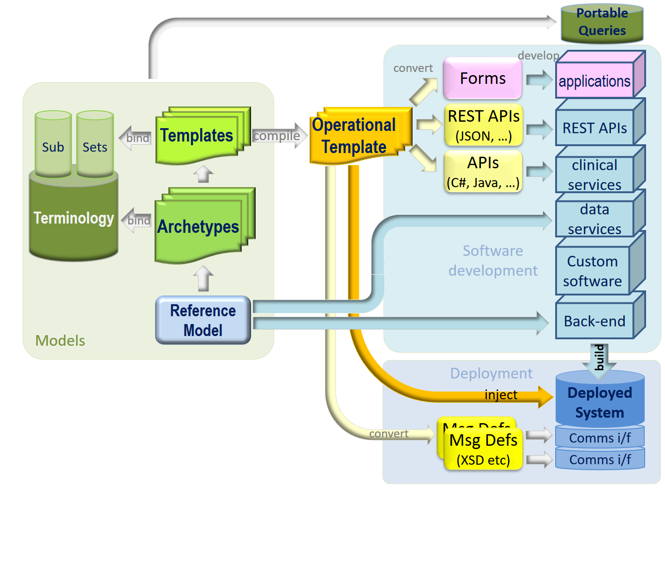

Analogous to CIMI and ISO13606,

1. The foundational artefact of the openEHR approach is its reference model - a very stable information model that defines the logical structures of EHR and demographic data. All EHR data in any openEHR system obey this reference model. The openEHR Foundation provides the reference model specification, which is a formal, logical definition of the information, not the concrete physical data schema.
2. The next level consists of a library of data points/data groups that are independent of particular use – these are called archetypes. The creation of a library of use-independent data points removes the need for modelling the same data point more than once. The international library of openEHR archetypes (**CKM**, See <http://www.openehr.org/ckm/>) currently contains about 500 archetypes, or 6,500 data points. Another advantage is that these archetypes can be modelled by clinical professionals or health informatics experts without any technological knowledge of the final EHR systems. The openEHR approach also allows making use of external health terminologies, such as SNOMED CT, LOINC and ICDx in the modelling process. The openEHR Foundation provides the archetype model specification and also tools for their authoring and editing.
3. At the next level, the data-points and data-groups are assembled into context-specific data sets – it could be the data for a form, a particular message, or a document. In openEHR, these are called templates. All openEHR systems are built with templates, which contain the relevant bits of various archetypes. Templates preserve the paths of archetype elements they use, even within variable depth structures. Templates are usually developed by implementers local to the solution being built, but it is also possible to build a standard template for a country, e.g. a discharge summary. The tools for template design and editing are provided by the openEHR Fondation.
4. The last level, closest to the user are template-generated artefacts, such as application program interfaces, XSDs, UI forms. These artefacts are used by application developers. The openEHR Foundation provides the operational template specification.

## ISO

The following ISO standards have been identified as impacting this recommended initiative and should be harmonized

1. The CEN/ISO EN13606 1-5 (EHRcom) is designed to achieve semantic interoperability in the electronic health record communication by defining a rigorous and stable information architecture for communicating part or all of the electronic health record (EHR) of a single subject of care (patient) between EHR systems, or between EHR systems and a centralized EHR data repository. It may also be used for EHR communication between an EHR system or repository and clinical applications or middleware components (such as decision support components) that need to access or provide EHR data, or as the representation of EHR data within a distributed (federated) record system. CEN/ISO 13606 follows an innovative Dual Model architecture. The Dual Model architecture defines a clear separation between information and knowledge. The former is structured through a Reference Model that contains the basic entities for representing any information of the EHR. The latter is based on archetypes, which are formal definitions of clinical concepts, such as discharge report, glucose measurement or family history, in the form of structured and constrained combinations of the entities of a Reference Model. It provides a semantic meaning to a Reference Model structure. The interaction of the Reference Model (to store data) and the Archetype Model (to semantically describe those data structures) provides an unseen capability of evolution to the information systems. Knowledge (archetypes) will change in the future, but data will remain untouched.
2. ISO EN 12967 (HISA) Standard Architecture Health Informatics Service Architecture provides guidance on the development of modular open [information technology](https://en.wikipedia.org/wiki/Information_technology) (IT) systems in the healthcare sector. Broadly, architecture standards outline frameworks which can be used in the development of consistent, coherent applications, databases and workstations. This is done through the definition of hardware and software construction requirements and outlining of protocols for communications.[[1]](https://en.wikipedia.org/wiki/Health_Informatics_Service_Architecture#cite_note-1) The HISA standard provides a formal standard for a [service-oriented architecture](https://en.wikipedia.org/wiki/Service-oriented_architecture) (SOA), specific for the requirements of health services, based on the principles of [Open Distributed Processing](https://en.wikipedia.org/wiki/Open_Distributed_Processing).[[2]](https://en.wikipedia.org/wiki/Health_Informatics_Service_Architecture#cite_note-2) The HISA standard evolved from previous work on healthcare information systems architecture commenced by Reseau d’Information et de Communication Hospitalier Europeen (RICHE) in 1989, and subsequently built upon by a number of organizations across Europe.[[3]](https://en.wikipedia.org/wiki/Health_Informatics_Service_Architecture#cite_note-3)
3. ISO EN 13940 (ContSys) The system of concepts to support continuity of care, often referred to as ContSys, is an ([ISO](https://en.wikipedia.org/wiki/International_Organisation_for_Standardization) and [CEN](https://en.wikipedia.org/wiki/European_Committee_for_Standardization) standard (EN ISO 13940).,[[1]](https://en.wikipedia.org/wiki/System_of_concepts_to_support_continuity_of_care#cite_note-ISO_13940:2015-1)[[2]](https://en.wikipedia.org/wiki/System_of_concepts_to_support_continuity_of_care#cite_note-EN_ISO_13940:2016-2) Continuity of care is an organizational principle that represents an important aspect of quality and safety in healthcare. [Semantic interoperability](https://en.wikipedia.org/wiki/Semantic_interoperability) is a basic requirement for continuity of care. [Concepts](https://en.wikipedia.org/wiki/Concept) that are needed for these purposes must represent both the content and context of the healthcare services.
4. ISO/TS 13972:2015: Health informatics -- Detailed clinical models, characteristics and processes Abstract Describe requirements and recommended methods against which clinicians can gather, analyse and, specify the clinical context, content, and structure of Detailed Clinical Models. Defines Detailed Clinical Models (DCMs) in terms of an underlying logical model. They are logical models of clinical concepts and can be used to define and to structure clinical information. Describes requirements and principles for DCMs, meta-data, versioning, content and context specification, data element specification and data element relationships, and provide guidance and examples.
5. SIAMM (Semantic Interpretability Artefact Modeling Method) is a complete set of requirements, defined concepts of things related to archetypes, systems and organizations they are used in. It also selects standards needed to create archetypes, and standard patterns to construct DCMs expressed as archetypes. SIAMM is loosely related to the ISO13606 Association. It defines concepts and a method to create re-usable patterns needed for Semantic Interpretability. It overlaps with CIMI and tales part in the CIMI project[13].

## SOLOR

SOLOR (SNOMED with LOINC and RxNorm extensions) is endorsed by the HSPC as a terminology foundation for interoperable decision support. SOLOR is a single integrated terminology which incorporates several terminology standards, including; but not limited to: SNOMED, RxNorm, and LOINC, into a logically integrated—and structurally normalized—foundation. While the three core-standards cover different types of content, SOLOR harmonizes the overlap between them, lending to opportunities for greater interoperability between systems. SOLOR will be the terminology content utilized within the Federal Health Information Model (FHIM), Clinical Quality Framework (**CQF**), and the Clinical Information Modeling Initiative (**CIMI**).



Figure 15: SOLOR with SNOMED extensions solve LOINC and RXNorm inconsistencies

SOLOR is the terminology content, based on the SNOMED CT Observation Model; where, SNOMED CT serves as a source of concepts for SOLOR semantic buildings as well as inferences. LOINC and RxNorm will be integrated into SOLOR using SNOMED CT’s shared Descriptive Logic (**DL**) model. DL terminologies are foundational allowing additional models to be built on top of, not independent of, the foundation. The benefits of having this normalized structure and form is that clinical terminology includes:

1. Improving software reuse;
2. Facilitating shared tooling;
3. Using a shared post-coordination model; and
4. Simplifying data analysis.
5. Allowing automated-reasoning aka logical-inferences

## LEGO

The Lightweight Expression of Granular Objects (**LEGO**) model is separate from SOLOR; but, LEGOs can also provide semantic model content and can be used to test the validity and consistency of models. LEGO construction is a content-modeling strategy based on the International Health Terminology Standards Development Organization (**IHTSDO**) Observables Model, which is for use in the Systematized Nomenclature of Medicine – Clinical Terms (**SNOMED CT**).

LEGOs can represent large amounts of detailed clinical data in a consistent and computable manner that can support multiple use cases. LEGOs represent question/answer pairs on clinical data collection forms, where a question is modeled by a (usually) post-coordinated SNOMED CT expression. LEGOs transform electronic patient data into a normalized consumable, which means that the expressions can be treated as extensions of the SNOMED CT hierarchies for the purpose of performing subsumption queries and other analytics. Using the LEGO approach for modeling clinical data provides a foundation for data exchange across disparate information systems and software applications. Clinical data exchange of computable LEGO patient information enables the development of more refined data analytics, data storage and clinical decision support.

When a LEGO discernible requires more than a single observable entity concept (in other words, when post-coordination is required), use of the IS ABOUT attribute is the preferred way to represent presence observables. The value of the IS ABOUT attribute in a LEGO discernible is frequently a SNOMED CT clinical disorder or procedure concept, while the <value> element of the assertion is often a SNOMED CT qualifier concept such as “Present” or “Absent.” The VA’s Informatics Systems Architecture Acceleration (**ISAAC**) project/editor LEGO Editor incorporates Lightweight Expression of Granular Objects (**LEGO**) functionality into the health IT Extraction, sharing and loading (**ETL**) software interoperability-stack.

## Termspace – Terminology Editing

Ontoserver® has been selected as the terminology server for HSPC. Ontoserver is a terminology server developed by the Commonwealth Scientific and Industrial Research Organization ([CSIRO](https://ontoserver.csiro.au/index.html)), based in Australia, that supports multiple versions of SNOMED CT (and extensions), LOINC and other standard terminologies. Ontoserver focuses on terminology use, not authoring. After the SOLOR content is authored in Termspace, it will be released as a Release Format 2 (**RF2**) module and loaded into Ontoserver.

Ontoserver contains a simple REST API and FHIR (Fast Health Interoperability Resources) STU3 terminology services, which will be accessed by applications using the SOLOR terminology content. Ontoserver is currently being configured with terminology content; where, a stable production version 1.0 is targeted to be available on or before 31 Oct 2017. “Shrimp” is the freely available Ontoserver SNOMED browser.

## Ontoserver – Terminology Server

Ontoserver® has been selected as the terminology server for HSPC. Ontoserver is a terminology server developed by the [CSIRO](https://ontoserver.csiro.au/index.html) Ontoserver that supports multiple versions of SNOMED CT (and extensions), LOINC and other standard terminologies. Ontoserver focuses on terminology use, not authoring. After the SOLOR content authored in Termspace, it will be released as a Release Format 2 (**RF2**) module and loaded into Ontoserver. Ontoserver contains a simple REST API and FHIR (Fast Health Interoperability Resources) terminology services (STU3) which will be accessed by applications using the SOLOR terminology content. Currently, Ontoserver is currently being configured with terminology content; where, a stable production version 1.0 is targeted to be available on or before 31 Oct 2017. “Shrimp” is the Ontoserver SNOMED browser.

## VSAC

The Value Set Authority Center (**VSAC**) is provided by the National Library of Medicine (**NLM**), in collaboration with the Office of the National Coordinator for Health Information Technology and the Centers for Medicare & Medicaid Services. The VSAC provides downloadable access to all official versions of vocabulary value sets contained in the 2014 electronic Clinical Quality Measures (**eCQMs**); where, each value set consists of the numerical values (codes) and human-readable names (terms), drawn from standard vocabularies such as SNOMED CT®, RxNorm, LOINC and ICD-10-CM, which are used to define clinical concepts used in clinical quality measures (e.g., patients with diabetes, clinical visit). For information on the eCQMs, visit the [electronic Clinical Quality Initiative (eCQI) Resource Center](https://ecqi.healthit.gov/). The content of the VSAC will gradually expand to incorporate value sets for other use cases, as well as for new measures and updates to existing measures.

In the short term, the current HSPC SOLOR Ontoserver serves as a sandbox development server; where, VSAC can be used for value sets and the HSPC Ontoserver server is used for code systems. This allows pilot studies to prototype SOLOR SNOMED extension requirements[14] and provide code-system requirements to NLM. CIMI plans to use VSAC exclusively, after the code system requirements are defined and stable and NLM‘s VSAC supports those code system requirements.

## STAMP Versioning

STAMP (Status, Time, Author, Module, Path) methodology will be used for the versioning and maintenance of Clinical-Knowledge content. STAMP is a comprehensive option for managing SOLOR version control and maintenance. The fundamental goal of STAMP is to provide a single, coherent and robust version control process that spans every layer and component involved in the authoring of clinical knowledge content; clinical decision support rules, clinical quality measures, value-set definition and the new expansions and extensions to existing clinical ontology concepts on which they will all depend. There will be STAMP repositories setup within HSPC for projects that span multiple clinical teams and communities to support critical, high-profile content development efforts.

STAMP is:

1. A standard for the metadata that must be retained during each editing event
2. An Open-Source implementation of the version-control web service.

The SMART architecture and schema for the metadata to be retained during the authoring process, is inspired by the best practices that exist in the software development community. Termspace and Ontoserver have been adapted to support the STAMP versioning platform.

By rationalizing version control practices across all layers of the clinical content stack, complex dependencies and release practices can be organized, administered and tracked as one. As clinical work-products are deployed in the field, and therefore must be maintained, robust tooling will exist to highlight and guide that maintenance effort.

By rationalizing version control practices across all layers of clinical content stack, complex dependencies and release practices can be organized, administered and tracked – as one. And as clinical work-products are deployed in the field, and therefore must be maintained, robust tooling will exist to highlight and guide that maintenance effort.

## SMART

“SMArt” (Substitutable Medical Applications, reusable technologies) architecture, provides core services and support extensively networked data from across the health system, as well as facilitate substitutable applications – enabling the equivalent of the iTunes App Store for health. This approach to a health information infrastructure started with a June 2009 working group meeting at the Harvard Medical School Center for Biomedical Informatics and an October ONC HIT meeting which brought together more than 100 key stakeholders across academia, government and industry in an exploration of innovative ways to transform the national health IT system.

## SIGG (MDHT, MDMI)

Model Driven Healthcare Tools (MDHT) and Model Driven Message Interface (MDMI) are complementary Model Driven Development tooling projects, based on Object Management Group (**OMG**) standards that deliver the capability for a Semantic Interoperability Guide Generator (**SIGG**). MDHT is an open source project at Eclipse.org that supports a full development lifecycle using the Unified Modeling Language (**UML**) for model design, transformation between alternative model representations, Java code generation, and testing/validation of instance data. MDMI open-source tools define and leverage a shared dictionary of semantic business artifacts that are assigned to model artifacts in various logical and implementation models for healthcare data, including FHIM, C-CDA, FHIR, and others. MDMI + MDHT enables automated generation of Traceability and Gap Analysis reports between any of the mapped models, plus generation of target model profiles for the identified gaps, e.g. FHIR profiles. MDMI tools also include a runtime platform for transforming mapped instances of healthcare data, e.g. C-CDA documents to FHIR resources.

## Conclusion

The evolving Figure 9 IIM&T Model Driven Development Strategy and Figure 11: IIM&T Roadmap, and Figure 14 CIMI Methodology construct re-usable logical information-model building-block specifications for implementable HL7 FHIR, CDA, V2 and V3 messages plus JSON APIs, NIEM etc. artifacts and SMART component-based architectural building-blocks empowering implementers, system developers-and-integrators and vendors to provide efficient-and-effective computable semantic-interoperability among ad-hoc systems (aka plug-and-play interoperability).

# Acknowledgement

*Collaboration that Grows with a Strong SME Base*

CIMI Co-Chairs

* Stanley Huff, Intermountain Healthcare
* Linda Bird BIT, IHTSDO
* Galen Mulrooney, FHA and VA contractor
* Richard Esmond, PenRad LLC

Members of the following SDOs

* HL7: CBCC, CIC, CDS, CQI, DEV, EHR, EST, FMG, HSI, PC, Security, SOA, Vocab
* IHTSDO, POC: Linda Bird BIT
* The Open Group Healthcare Forum POC: Jason Lee
* ISO/CEN, POCs: Gerard Freriks, William Goossen, Gary Dickinson

Federal Agency staff and contractors

* Office of the National Coordinator,
* Office of Science and Technology (ONC OST)
* Federal Health Architecture (FHA)
* Interagency Program Office (IPO),
* Defense Health Agency (DHA),
* Veterans Administration (VA)
* Federal Drug Agency (FDA),
* Center for Disease Control (CDC)
* Substance Abuse and Mental Health Services Administration (SAMHSA)
* MITRE, Apprio Inc, Cognitive Medicine, Iris Health Solutions LLC, JP Systems

Members of the following Healthcare Organizations

* Intermountain Healthcare,
* PenRad, Inc.,
* Results4Care, Health Services Platform Consortium (HSPC)

Faculty, Staff and Students

* Duke University,
* The University of Utah

|  |
| --- |
|  |

# Acronyms and Links

* **BMM** is CIMI Reference Model (Information Architecture) Basic Meta Model components
* http://wiki.hl7.org/index.php?title=CIMI_Practitioners%27_Guide
* **CDA** is HL7 Clinical Data Architecture.
* See http://www.hl7.org/implement/standards/product_brief.cfm?product_id=258
* **C-CDA** is HL7 Consolidated CDA.
* See http://www.hl7.org/implement/standards/product_brief.cfm?product_id=379
* **CEM** is Intermountain Clinical Element Models. See http://www.opencem.org/#/
* **CDS** is HL7 Clinical Decision Support workgroup. Seehttp://wiki.hl7.org/index.php?title=Clinical_Decision_Support
* **CIMI** is HL7 Clinical Information Model Initiative.
* See http://wiki.hl7.org/index.php?title=Clinical_Information_Modeling_Initiative_Work_Group
* **CIMI Principles** See http://wiki.hl7.org/index.php?title=CIMI_Practitioners%27_Guide
* **CIMI Reference Models (aka Information Architecture)** See http://wiki.hl7.org/index.php?title=CIMI_Practitioners%27_Guide
* **CLIM** is HL7 Clinical Logical Information Model Package of CIMI-Harmonized SOLOR, FHIM, CQF, CIMI DCMs and CQI KNARTs
* where, independent organizations maintain the component models and HL7 periodically configuration manages, ballots and standardizes them.
* **CQF** is ONC Clinical Quality Framework. See http://wiki.hl7.org/index.php?title=Clinical_Decision_Support
* **CQI** is HL7 Clinical Quality Initiative workgroup. See http://wiki.hl7.org/index.php?title=Clinical_Quality_Information
* **DAF** is ONC Data Access Framework (US Core). See http://wiki.siframework.org/Data+Access+Framework+Homepage
* **DCM** is CIMI Detailed Clinical Models. See http://www.opencimi.org/model-browser
* **FHIM** is Federal Health Information Model. FHIM specifies 30+ healthcare domains. http://FHIMS.org
* **FHIR** is HL7 Fast Healthcare Information Resource standard and workgroup. Seehttp://wiki.hl7.org/index.php?title=FHIR
* **HcDir** is ONC-FHA Provider Healthcare Directory. Seehttp://wiki.siframework.org/Provider+Directories
* **IIM&T** Is CIMI-sponsored HL7 Integration of Information Models & Tools Project.
* http://wiki.hl7.org/index.php?title=CIMI_Practitioners%27_Guide
* **JET** is DoD-VA Joint Exploratory Team.
* **KNART** is CDS Knowledge Artifact. See http://www.hl7.org/implement/standards/product_brief.cfm?product_id=337
* **MDHT** is SIGG Model Driven Health Tool. See https://projects.eclipse.org/proposals/model-driven-health-tools
* **MDMI** is SIGG Model Driven Message Interoperability.
* The present MDMI Referent Index (RI) scope is the US Core; where, FHIM is used for data-element value-sets.
* FHA’s MDMI RI supports all MU2 data elements and >90% of the C-CDA model.
* See http://www.omg.org/mdmi/and http://www.omg.org/spec/MDMI/
* See at https://github.com/MDMI/ReferentIndexContent
* **NIEM** is National Information Exchange Package. See https://www.niem.gov/
* **QI Core** is FHIR Quality Improvement Core Implementation Guide. See https://www.hl7.org/fhir/qicore/qicore.html
* **QUICK** is CQI Quality Information and Clinical Knowledge logical model, used to specify eCQMs and FHIR QI Core.
* See https://www.hl7.org/documentcenter/public_temp_315E0F18-1C23-BA17-0C73398BA144AB5D/wg/cqi/Defining_eCQMs_Using_CQL.pdf
* **RI** is SIGG-MDMI Referent Index. See https://github.com/MDMI/ReferentIndexContent
* **SIGG** is FHA Standards Implementation Guide Generator
* **SOLOR** is VA’s SnOmed LOinc, Rxnorm. HSPC hosts the SOLOR terminology editing environment.
* **VSAC** is NLM Value Set Authority Center. <https://vsac.nlm.nih.gov/>

# Acronym Cross-Reference Index

API, 31

**BMM**, 3, 4, 8, 9, 10, 11, 17, 18, 20, 25, 27, 28, 38

C-CDA, 37

CDA, 19, 22, 26, 27, 28, 30, 32, 37, 38

CDS, 3, 16, 19, 26, 31, 37, 38, 40

CEM, 18, 38

CEN, 33

**CIMI**, 1, 2, 3, 4, 5, 7, 8, 9, 10, 11, 14, 15, 16, 17, 18, 19, 20, 22, 23, 25, 27, 28, 29, 30, 31, 32, 33, 34, 36, 37, 38, 40

CLIM, 2, 18, 19, 22, 30, 38

ContSys, 33

CQF, 2, 3, 5, 7, 16, 18, 19, 20, 22, 23, 30, 31, 34, 38, 40

**CQI**, 3, 16, 18, 19, 29, 31, 37, 38, 40

CQL, 3

**DAF**, 3, 17, 18, 38

DCM, 3, 8, 9, 11, 12, 13, 18, 20, 32, 38

DCMs, 2, 3, 19, 25, 27, 29, 30, 31, 32, 34, 38

eCQM, 18

EDW, 18

EHR, 4, 7, 15, 16, 22, 24, 26, 32, 33, 37, 40

ETL, 6, 19, 35

FDA, 4, 18, 37

FHA, 1, 18, 23, 25, 27, 37, 38, 40

FHIM, 2, 3, 4, 5, 7, 10, 16, 18, 19, 20, 22, 23, 25, 27, 29, 30, 31, 37, 38, 40

FHIR, 1, 2, 3, 4, 6, 8, 9, 16, 18, 19, 22, 23, 24, 25, 26, 27, 28, 29, 30, 31, 35, 37, 38

FHIR US Core, 3

HcDir, 18, 38

HeD, 16

HIEA, 18, 27

HISA, 33

**HIT**, 17, 19, 20, 36

HL7, 1, 2, 3, 7, 16, 17, 19, 23, 24, 25, 26, 27, 28, 30, 31, 32, 36, 37, 38, 40

HSPC, 1, 2, 3, 4, 5, 6, 7, 14, 19, 26, 34, 35, 36, 37, 38

IIM&T, 1, 2, 3, 4, 5, 7, 8, 9, 16, 17, 19, 20, 24, 25, 26, 27, 30, 37, 38, 40

IPO, 1, 4, 18, 23, 25, 26, 27, 37

ISAAC, 6, 18, 30, 35

ISO, 14, 15, 18, 19, 20, 23, 28, 30, 31, 32, 33, 34, 37

ISO EN 12967, 33

ISO EN 13940, 33

ISO13606, 34

**JET**, 26, 38

JIF, 18

JSON, 19, 37

KNART, 18, 19, 20, 38

LEGO, 5, 6, 20, 24, 35

LIM, 19, 20

LOINC, 2, 5, 6, 8, 9, 10, 14, 18, 22, 26, 30, 31, 33, 34, 35, 36

MDA, 36

MDD, 2, 8, 9

MDHT, 8, 9, 18, 20, 29, 30, 36, 38, 40

MDMI, 18, 20, 29, 30, 36, 38, 40

NIEM, 19, 22, 26, 27, 28, 30, 37, 38

NLM, 6, 7, 35, 36, 38

ONC, 1, 4, 7, 16, 18, 23, 25, 27, 36, 37, 38, 40

Ontoserver, 6, 7, 35, 36

openEHR, 32, 33

OST, 1, 18, 37, 40

PMP, 18

PSMs, 19, 20

PSS, 18, 27

**QI Core**, 3, 19, 25, 28, 29, 38

QUICK, 18, 19, 29, 38

RMIM, 32

RxNorm, 2, 5, 6, 26, 30, 31, 34, 36

RXNorm, 5, 18, 34

SIAMM, 34

SIGG, 18, 20, 24, 29, 30, 31, 36, 37, 38, 40

SMART, 5, 7, 19, 36, 37

SMEs, 2

SNOMED, 2, 5, 6, 7, 14, 15, 16, 17, 22, 26, 30, 31, 33, 34, 35, 36

SNOMED-CT, 31

SOA, 33

SOLOR, 2, 3, 5, 6, 7, 9, 14, 16, 18, 19, 20, 22, 23, 24, 26, 30, 31, 34, 35, 36, 38, 40

STAMP, 7, 20, 36

STU, 4, 18, 25

Termspace, 6, 7, 35, 36

TLC, 18

US Core, 3, 25, 28, 29, 38

V2, 19, 37

VA, 1, 4, 6, 7, 18, 26, 35, 37, 38, 40

VCS, 18

VSAC, 6, 7, 18, 35, 36, 38

**POCs (NOT FOR PUBLIC-DISTRIBUTION OR WEB-SITES)**

**HL7 IIM&T**

**Nona Hall,** Sr. Clinical Informaticist and CIMI Facilitator  
[Nona.G.Hall.civ@mail.mil](mailto:Nona.G.Hall.civ@mail.mil)

**Stephen Hufnagel,** FHIM-HL7 Facilitator  
[Stephen.Hufnagel.HL7@gmail.com](mailto:Stephen.Hufnagel.HL7@gmail.com)

**HL7 CIMI**

**Joey Coyle,** CME Modeler  
[joey@xcoyle.com](mailto:joey@xcoyle.com)

**Patrick Langford,** CIMI Tools Developer  
[Patrick@neuronsong.com](mailto:Patrick@neuronsong.com)

**Richard Esmond,** CIMI Developer in Radiology Area  
[Richard.Esmond@gmail.com](mailto:Richard.Esmond@gmail.com)

**Stan Huff,** CIMI Lead  
[Stan.Huff@imail.org](mailto:Stan.Huff@imail.org)

**Susan Matney,** CIMI Support, PC Wound Assessment POC, and Clinical SME  
[Susan.Matney@imail.org](mailto:Susan.Matney@imail.org)

**CQI/CDS/CQF**

**Claude Nanjo,** CQI/CQF Liaison for CQI/CQF and CDS [cnanjo@cognitivemedicine.com](mailto:cnanjo@cognitivemedicine.com)

**Julia Skapik,** OST/ONC POC and CQF Proponent  
[Julia.Skapik@hhs.gov](mailto:Julia.Skapik@hhs.gov)

Kensaku Kawamoto, CDS, [kensaku.kawamoto@utah.edu](mailto:kensaku.kawamoto@utah.edu)

Floyd Eisenberg, CQI

**FHA**

Gail Kalbfleisch, Director, Federal Health Architecture.

**FHA FHIM**

**Galen Mulrooney,** FHIM UML Modeler  
[Galen.Mulrooney@JPSys.com](mailto:Galen.Mulrooney@JPSys.com)

**Steven Wagner,** FHIM Project Manager  
[switconsulting@comcast.net](mailto:switconsulting@comcast.net)

**Jay Lyle,** FHIM Terminologist, PC Wound Assessment POC, and SME  
[Jay.Lyle@jpsys.com](mailto:Jay.Lyle@jpsys.com)

**Robert McClure,** FHIM Clinical SME, and HL7 Vocab **POC**  
[rmcclure@mdpartners.com](mailto:rmcclure@mdpartners.com)

**Sean Muir,** Supports FHIM, and SIGG/MDHT/MDMI Developer  
[Sean.Muir@jkmsoftware.com](mailto:Sean.Muir@jkmsoftware.com)

**FHA SIGG**

**Dan Morford,** SIGG Program Manager  
[Dan.morford@bookzurman.com](mailto:Dan.morford@bookzurman.com)

**Dave Carlson,** SIGG/MDHT Developer  
[Dave.Carlson@bookzurman.com](mailto:Dave.Carlson@bookzurman.com)

**Gail Kalbfleisch,** FHA Director, FHIM and SIGG Proponent  
[Gail.Kalbfleisch@hhs.gov](mailto:Gail.Kalbfleisch@hhs.gov)

**Ken Lord,** MDMI Developer  
[Ken.Lord@bookzurman.com](mailto:Ken.Lord@bookzurman.com)

**VA SOLOR**

**Apurva Desai,** Supports SOLOR  
[Apurva.Desai@pivotal-insight.com](mailto:Apurva.Desai@pivotal-insight.com)

**Franklin Cuello,** SOLOR Program Manager  
[Franklin.Cuello@pivotal-insight.com](mailto:Franklin.Cuello@pivotal-insight.com)

**Keith Campbell,** SOLOR Lead SME  
[Campbell@informatics.com](mailto:Campbell@informatics.com)

**Steven Douglass,** Supports SOLOR  
[sdouglass@getsamsnow.com](mailto:sdouglass@getsamsnow.com)

**Walter Sujansky,** SOLOR language type questions/issues

[wsujansky@sujansky.com](mailto:wsujansky@sujansky.com)

**Monique van Berkum**

[Monique.vanBerkum@va.gov](mailto:Monique.vanBerkum@va.gov)

**Kilbourne, John, MD**

John.Kilbourne@va.gov

|  |
| --- |
|  |

DISTRIBUTION LIST (NOT FOR PUBLIC-DISTRIBUTION OR WEB-SITES)

**TO:** Julia.Skapik@hhs.gov; Campbell@informatics.com; Nona.G.Hall.civ@mail.mil; Stan.Huff@imail.org; switconsulting@comcast.net

**CC:** cimi@lists.hl7.org; EHR@lists.hl7.org; patientcare@lists.hl7.org; security@lists.hl7.org; CIClist@lists.hl7.org; Devicesonfhir@lists.hl7.org; DSS@lists.hl7.org; CQI@lists.hl7.org; HSI@lists.hl7.org; SOA@lists.hl7.org; cbhs@lists.hl7.org; fmg@lists.hl7.org; Security@lists.hl7.org; federal.health@hhs.gov; akling@mitre.org; alan.bartholomew1.civ@mail.mil; Alberto.Llanes@hhs.gov; Ali.Strickland@hhs.gov; allanes@irishealthsolutions.com; Apurva.Desai@pivotal-insight.com; Carmen.Smiley@hhs.gov; cnanjo@cognitivemedicine.com; dakkor@irishealthsolutions.com; Dan.morford@bookzurman.com; David.Bobb@hhs.gov; david.a.tuttle12.ctr@mail.mil; David.Bass3@va.gov; dcarlson@xmlmodeling.com; doug@rosendale.us; eileen.k.luterzo.ctr@mail.mil; Elaine.Hunolt@va.gov; Franklin.Cuello@pivotal-insight.com; Gail.Macik@va.gov; Galen.Mulrooney@JPSys.com; Greg.Staudenmaier@va.gov; Harold.Demmings@va.gov; Javon.Hyland@va.gov; jay.lyle@jpsys.com; jdecamp@apprioinc.com; jforrester@irishealthsolutions.com; jglace@mitre.org; John.Kilbourne@va.gov; ken.lord@bookzurman.com; kensaku.kawamoto@utah.edu; kolar.mahesh@va.gov; Lauren.Richie@hhs.gov; lynnpmartin1744@gmail.com; mario.hyland@aegis.net; Matthew.Rahn@hhs.gov; melonia.lillie@initiatesolutions.com; Mera.Choi@hhs.gov;. Michael.Wittie@hhs.gov; mkramer@mitre.org; monica.f.farahstapleton.civ@mail.mil; Monique.vanBerkum@va.gov; nancy.j.orvis.civ@mail.mil; Prathibha.Gattadahalli@va.gov; Reginald.W.Humphries@leidos.com; Rene.Kinsey@va.gov; richard.esmond@gmail.com; rmcclure@mdpartners.com; Robert.Anthony@hhs.gov;. Robert.Bishop2@va.gov; sdouglass@getsamsnow.com; sean.muir@jkmsoftware.com; shufnagel@apprioinc.com; skafle@mitre.org; Susan.Matney@imail.org;; Terry.Luedtke@va.gov; thokel@DELOITTE.com; thomas.a.hokel.ctr@mail.mil; Vicki.Hitchcock@initiatesolutions.com; wsujansky@sujansky.com; yiwen.y.tang2.civ@mail.mil;

1. **Rob McClure** stated the CIMI’s approach to SNOMED extensions must be clearly defined to obtain HL7 Vocab concurrence to HL7 ballot CIMI models.
2. See http://wiki.hl7.org/index.php?title=PC_CIMI_Proof_of_Concept
3. See article at <https://1drv.ms/b/s!AlkpZJej6nh_lMxsPzWykUFysb8qWw> and

   ISO 13606 excerpt at <https://1drv.ms/b/s!AlkpZJej6nh_lMxtHOeJbKO2HyeSTg>
4. IIM&T is Integrated Information Model Tools, Hl7 Project# 1316. IIM&T collaborates in the development, standardization and use of IIM&T architectural framework and reusable artifacts producing HL7 and ISO standards. <http://www.hl7.org/special/Committees/projman/searchableProjectIndex.cfm?action=edit&ProjectNumber=1316>
5. HSPC is Healthcare Services Platform Consortium, a provider-led and vender involved collaboration among 200-300 government, industry and academic healthcare leaders dedicated to establishing a scale-able, truly interoperable SMART data-services, component and application system-architecture for HIT. See <http://hspconsortium.org/>
6. See SMArt (Substitutable Medical Apps, reusable technologies) platform architecture at <https://www.healthit.gov/policy-researchers-implementers/substitutable-medical-apps-reusable-technologies>
7. Governance involves change control, configuration management and version control; where, CLIM governance is generally federated. That is, local development organizations govern their own artifacts and may wish to provide versions to HL7. Appropriate HL7 workgroups govern HL7 artifacts and ballots. Similarly, FHIR governance is generally federated; where, local development organizations govern their own artifacts and may wish to provide versions to HL7. At HL7, FHIR-compliant reusable-artifacts are governed by the FHIR workgroup’s HL7 artifacts and ballots.
8. Information Model: (in software engineering) a representation of concepts, relationships, constraints, rules and operations to specify data semantics for a chosen domain of discourse. It can provide sharable, stable, and organized structure of information requirements for the domain context. Logical Information Model (LIM): (in systems engineering) a representation of information, organized in terms of classes and relationships and is independent of any particular technology (database) platform. The logical information model can become the basis of a physical data model and inform the design of a database. Logical information and physical data models (i.e., PSMs) are very different in their objectives, goals and content.
9. A platform-specific model (PSM) is a model of a software or business system that is linked to a specific technological platform (e.g. a specific programming language, operating system, document file format or database). Platform-specific models are indispensable for the actual implementation of a system.
10. The Open Group Healthcare Forum collaboration is among industry stakeholders, regulatory bodies, other standards-setting organizations, and other consortia concerned with healthcare interoperability.
11. See MedInfo 2010 Paper by William TF Goossen, Anneke Goossen-Baremans at <https://1drv.ms/b/s!AlkpZJej6nh_k9Rnx_BKY2zsDNrlvg>
12. See http://www.openehr.org/
13. See <https://1drv.ms/b/s!AlkpZJej6nh_k9NVZccvKSQ7HJyYiQ>
14. **Rob McClure** stated the CIMI’s approach to SNOMED extensions must be clearly defined to obtain HL7 Vocab concurrence to HL7 ballot CIMI models.